

**Title I Guidelines and Procedures**



**2022-2023**

**School Year**

**Guide to Use** 4

**Title I Information** 5

Title I Staff6

Every Student Succeeds Act (ESSA) 7

Title I Schools 9

Title I Comprehensive School Wide Planning 10

Title I Components Clarification 12

Title I Low Performing Schools 14

NCStar 15

2022-2023 Title I Schools 19

**School Improvement**

Highlights of ESSA 21

Title I Schoolwide Program Calendar 26

Transportation 28

**Title I Plan/Budget Information**

Guidelines for Using Title I Funds 30

Title I Budget 31

Title I Allowable and non-Allowable Cost Reference Guide Examples 33

Title I Funding 37

Sample Title I (050) Allocation Summary 38

**Purchase Orders/Invoices/Reimbursements**

The Process of Submitting a Purchase Order Using Title I Funds 40

Title I Purchasing Guidelines 41

Things to Remember 43

Workshop/Reimbursement Checklist 45

Sample Estimate of Travel Expenditures Form 46

Sample Purchase Order-Ordering Supplies 47

Sample Purchase Order: Parent Involvement Reimbursement 48

Sample Purchase Order Review 49

**Contract, Notice to Pay and Timesheets**

Contract Reminders 51

Title I Timesheets 52

Sample Copy of Employee’s Daily and Monthly Time Report 53

**Parent Family Engagement**

Parental Family Engagement Activities 55

Parent Family Engagement Evaluation 56

Example Elementary School Title I PE Policy 57

Parent Engagement Policy Requirements 60

Parent Family Engagement Plan 62

**Forms**

Semi-Annual Blanket Certification: Pre-K **(Aug.-Dec.)** 65

Semi-Annual Blanket Certification: Pre-K **(Jan.-June)** 66

Semi-Annual Blanket Certification: Federal 050 **(Aug.-Dec.)** 67

Semi-Annual Blanket Certification: Federal 050 **(Jan.-June)** 68

Title I Parent Meeting Sign-In Sheet 69

Move Money Form 70

Principal Attestation 71

Expense Reimbursement 72

Estimate of Travel Expenditures Form 73

Requisition Form 74

Equipment/Instructional Materials Disposition Form 75

PCS Student/Parent/Teacher/Principal Contract 76

Parent/School Compact 78

**Monitoring**

Cross Program Consolidated Monitoring80

**Guide to Use**

This guide was created to answer questions that administrators, office staff, teachers, and others may have regarding compliance to federal guidelines as they relate to the operation of Title I programs. General information is provided in the enclosed sections, followed by forms referenced in the guide. Title I and Pitt County Schools’ guidelines are constantly changing. Please note that the contents are current to the time of publication. Updates will be provided as appropriate.



**Title I Information**



**Federal Programs Office Staff**

**LaVette Ford**

Federal Programs Director

[fordl@pitt.k12.nc.us](mailto:fordl@pitt.k12.nc.us)

252.695.7950

|  |  |
| --- | --- |
| **Shonda Adams**  ESL Testing Specialist  [adamss2@pitt.k12.nc.us](mailto:adamss2@pitt.k12.nc.us)  252.695.7953 | **Hannah Butler**  Coordinator of Global Education  [butlerh@pitt.k12.nc.us](mailto:butlerh@pitt.k12.nc.us)  252.695.7957 |
| **LaReesha Carter**  Federal Programs Administrative Support  [carterl@pitt.k12.nc.us](mailto:carterl@pitt.k12.nc.us)  252.695.7951 | **Patricia Cox**  Title I Specialist  [coxp@pitt.k12.nc.us](mailto:coxp@pitt.k12.nc.us)  252.695.7956 |
| **Priscila Kelly**  Bilingual Family Liaison  [kellyp@pitt.k12.nc.us](mailto:kellyp@pitt.k12.nc.us)  252.695.7954 | **Twanda Staton**  Parent Engagement Coordinator  statont2@pitt.k12.nc.us  252.695.7952 |
| **Sonja Warren**  Federal Grants Financial Analyst  [warrens@pitt.k12.nc.us](mailto:warrens@pitt.k12.nc.us)  252.830.4253  252.830.4262 (fax)  1717 West Fifth Street  Greenville, NC 27834 | Title I at SFMHS - South Fort Myers High School |

Title I

Pitt County Schools

1058 Moye Blvd

Greenville, NC 27834

**(Tel.) 252.695.7951 (Fax) 252.752.2907**

**INTRODUCTION**

On December 10, 2015, President Obama signed the bipartisan Every Student Succeeds Act (ESSA), which reauthorizes the Elementary and Secondary Education Act of 1965 (ESEA). The ESSA builds upon the critical work States and local educational agencies (LEAs) have implemented over the last few years. The reauthorized law prioritizes excellence and equity for our students and supports great educators.

ESSA includes provisions that will help to ensure success for students and schools. Below are just a few. The law:

* Advances equity by upholding critical protections for America's disadvantaged and high-need students.
* Requires—for the first time—that all students in America be taught to high academic standards that will prepare them to succeed in college and careers.
* Ensures that vital information is provided to educators, families, students, and communities through annual statewide assessments that measure students' progress toward those high standards.
* Helps to support and grow local innovations—including evidence-based and place-based interventions developed by local leaders and educators—consistent with our [Investing in Innovation](http://www2.ed.gov/programs/innovation/index.html) and [Promise Neighborhoods](http://www2.ed.gov/programs/promiseneighborhoods/index.html)
* Sustains and expands this administration's historic investments in increasing access to high-quality [preschool](http://www.ed.gov/early-learning).
* Maintains an expectation that there will be accountability and action to effect positive change in our lowest-performing schools, where groups of students are not making progress, and where graduation rates are low over extended periods of time.

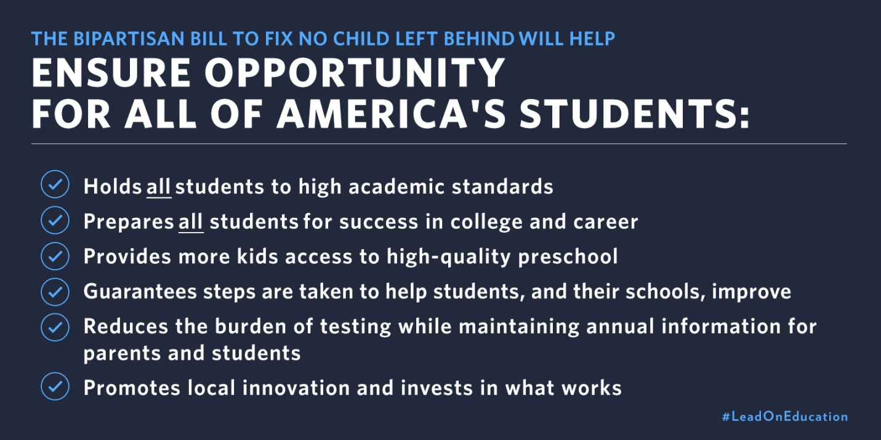

**Title I Schools**

**2022-2023**

**Ayden Elem. (PK-5) Ayden Middle (6-8) Belvoir (PK-5)**

**Bethel (PK-8) C.M. Eppes (6-8) Creekside (K-5)**

**Eastern (K-5) E.B. Aycock (6-8) Elmhurst (K-5)**

**Falkland (K-5) Farmville Middle (6-8) Grifton (PK-8)**

**G.R. Whitfield (PK-8) H.B. Sugg (PK-2) Innovation HS (9-12)**

**Lakeforest (PK-5) Northwest (PK-5) Pactolus (PK-8)**

**PCS Early College (9-12) Ridgewood (K-5) Sam D. Bundy (3-5)**

**South Greenville (PK-5) Stokes (K-8) Wahl-Coates (PK-5)**

**Wellcome (6-8) W.H. Robinson (K-5)**

**Title I Comprehensive School-wide Planning**

**SCHOOL**

**in consultation with**

**LEA**

**PARENTS**

**COMMUNITY**

**TECHNICAL**

**ASSISTANCE PROVIDER**

Entire school community responsible for success and growth of every student—”No Excuses”

* **5-Step Process**

1. Establish the Title I team

2. Clarify the vision for reform

3. Create a school profile

4. Identify data sources

5. Analyze the data

* **Analyze and review the existing plan**
  + Describe how the school will carry out each of the required school wide components
  + Describe how the school will use Title I resources and other resources to carry-out the school wide

components

* + Include a list of State and local programs the school will consolidate in the school wide program
  + Be evaluated annually—looking at both program implementation and achieved results
  + Be revised as necessary to ensure continuous student improvement
* **Identify the 10 school wide components in your plan**  [[Title I section 1114(b)(1)]

1. Comprehensive needs assessment summary

2. School reform strategies

3. Highly qualified personnel

4. High quality and ongoing professional development

5. Strategies to attract and retain highly qualified staff

6. Parent involvement

7. Transition strategies

8. Teacher involvement in assessment use

9. Instructional activities for students experiencing difficulty

10. Coordination/integration of federal, state, and local services/programs

**Focus on High Student Achievement**

* Include school vision and mission
* Address identified educational priorities
* Develop in collaboration with other school programs (e.g., EC, AG, grant-funded, individual school

initiatives

* Address areas that impact student achievement (e.g., student needs, curriculum and instruction, professional development, family and community involvement, school context and organization)

**High Expectations**

* Work hard to succeed—both teachers and students
  + Challenge students to think more deeply, apply new knowledge and skills, and become self-

motivated learners

* + Challenge each staff member to believe in each student’s ability to achieve to high standards
* Focus on intensive, early intervention to bring students up to grade level
* Provide opportunities for students to build meaningful relationships with adults
* Write **S**.**M**.**A**.**R**.**T**. goals

**S**: Specific (clear and explicit)

**M**: Measurable (accomplishment)

**A**: Attainable (realistic and controllable)

**R**: Relevant (related to identified needs)

**T**: Time bound (beginning, interim, end)

**Data-driven Instruction**

* Use data to identify students’ strengths and weaknesses
* Use multiple data sources (profiles, surveys, formal and informal assessments, student work

samples) to make informed decisions

* Use data to make informed decisions and determine areas of need
* Use multiple daily and weekly student assessments for ongoing data collection
* Focus on mastery by monitoring student progress using assessments to calibrate and retool
* Adjust teaching strategies to meet students’ needs based on the data

Analyze the

**Analyze the Data**

* Establish a process to review the data
* Determine any gaps between the vision and the current findings
* Summarize the data
* Draw conclusions
* Share the findings with the educational community
* Prioritize the needs
* Determine how to meet the needs
* Build an ongoing plan to facilitate continuous planning

Comprehensive

**Professional Learning**

* Seek opportunities to acquire new content knowledge and instructional skills
* Share what works—skills and strategies—with one another
* Establish learning communities—vertical teams made up of teachers, aides and staff, cutting across

grade levels

* Include culturally responsive training in content and skills
* Collaborate with colleagues to identify solutions to barriers

**Parent Outreach**

* View parents as critical partners in the educational process
* Solicit and facilitate parental participation
* Create opportunities for parents to join in the life of the school and share learning experiences with

their children

* Offer parents opportunities to collaborate with the school both when planning and making

decisions about their child

* Create a climate of cooperation between school, parents, and the community

Comprehensive

**Can-do Spirit**

* Commit to continuous student progress
* Convey genuine caring
* Honor students and their heritages
* Extend learning time
* Give students access to timely, effective, extra instruction if necessary
* Use rigorous and challenging content standards
* Accelerate and enrich the curriculum
* Teach them to learn with understanding
* Provide opportunities to excel in areas of special interest

**Title I Components Clarification**

**School Reform Strategies**

* Identify low performing areas and strategies used to address those areas
* Instructional strategies that support school wide reform or improvement

(Thinking Maps, coaches, SIOP, etc.)

* Procedures to identify low performing students, strategies need for those students, how progress will be monitored, and how parents are informed of progress.
* Specific strategies used to decrease achievement gap
* Describe availability of extended day opportunities that address increasing student achievement (tutoring/remediation, before, after or during)
* Describe procedure for identifying and targeting minority, poverty and language limited students and strategies used to address the needs of these populations.

**Highly Qualified Staff**

* Identifying professional development activities to enhance instructional practices
* Plan for all provisionally licensed teachers and teacher assistants to become highly qualified
* Plan to ensure that all staff is HQ by monitoring staff placement

**Teacher Recruitment and Retention**

* How you use assessment data to place highly qualified teachers in areas of need, including the use of “reduced class size” positions.
* Strategies used to recruit/retain highly qualified teachers
* Recruitment initiatives at the schools level in terms of climate issues, administrative support for teachers (planning, staff development, lead teacher and/or mentor support) and any incentive program that may exist.

**Grade Transition: PreK – K, Elem., Middle, and/or Middle-High School**

* Describe your transition strategies and how transition entities work with one another (ex. How do you plan activities at your school to help students transition from one grade to another)
* Programs that transition from one grade to the next (PBIS, etc.)

**HQ Staff Development**

* Target staff development that address specific subgroups
* Schoolwide training for all certified teachers and teacher asst.
* Supports research based strategies/district goals

**Instructional At-Risk/Assistance**

* Lists steps or provide copy of procedures to identify students of placement in Exceptional Children’s Programs, ESL/LEP, etc.
* Describe professional development activities planned that will assist teachers in teaching and addressing needs of student s with identified needs and different learning styles.
* Discuss how technology and extended day opportunities are used to address needs of this population
* Strategies used to improve instruction with at-risk students
* Programs that address the needs of at-risk student population

**Teacher Involvement/Input**

* Describe how teachers use data to drive instruction? Analyze data and assessments to improve instruction.
* Teachers developing assessments using technology to improve student performance.
* Teacher knowledge of using different assessment with students

**Federal, State and Local Support**

* Describe collaborations you have with other programs, grants, agencies or local/civic or church organizations.
* Local or district wide initiatives/programs
* Programs supported by DPI
* Strategies are supported by federal, state or local funds

**Parent Involvement**

* Events that promote student involvement across the curriculum
* Annual Title I meeting activities
* Activities that promote a positive home/school relationship
* Strategies that enhance communication between school and parents

**2022-2023**

**Title I Low Performing Schools**

-Belvoir -Northwest

-C.M. Eppes -South Greenville

-Lakeforest -Wahl-Coates

**Targeted Support and Improvement Schools**

**(TSI) Consistently Underperforming Subgroups 2021-22 Identification List**

|  |  |  |
| --- | --- | --- |
| **SCHOOL NAME** | **GRADE SPAN** | **QUALIFYING SUBGROUPS FOR TSI-CU**  **EDS=Economically Disadvantaged Students**  **ELS=English Learners**  **SWD= Students with Disabilities** |
| A.G. Cox Middle | 06-08 | SWD |
| Ayden Elementary | PK-05 | ELS, SWD |
| Ayden Middle | 06-08 | ELS, SWD |
| Belvoir Elementary | PK-05 | SWD |
| Bethel Elementary | PK-08 | SWD |
| C.M. Eppes Middle | 06-08 | SWD |
| Creekside Elementary | PK-05 | SWD |
| Falkland Elementary | 0K-05 | Hispanic, SWD |
| Eastern | 0K-05 | SWD |
| E.B. Aycock | 06-08 | SWD |
| Farmville Middle | 06-08 | SWD |
| Grifton | PK-08 | SWD |
| G.R. Whitfield | PK-08 | SWD |
| H.B. Sugg | PK-02 | SWD |
| Hope Middle | 06-08 | SWD |
| J.H. Rose High | 09-12 | SWD |
| Lakeforest | PK-05 | SWD |
| North Pitt High | 09-12 | ELS |
| Northwest Elementary | PK-05 | SWD |
| Pactolus | PK-08 | SWD |
| Vidant Health | PK-12 | SWD |
| W.H. Robinson | PK-05 | SWD |
| Sam D. Bundy | 03-05 | SWD |
| South Central | 09-12 | SWD |
| South Greenville Elementary | 0K-05 | Black, EDS, SWD |
| Stokes | PK-08 | SWD |
| Wahl Coates Elementary | PK-05 | SWD |
| Wellcome | 06-08 | SWD |

**\*TSI Schools for the 2022-2023 school year were identified in Fall 2021.**

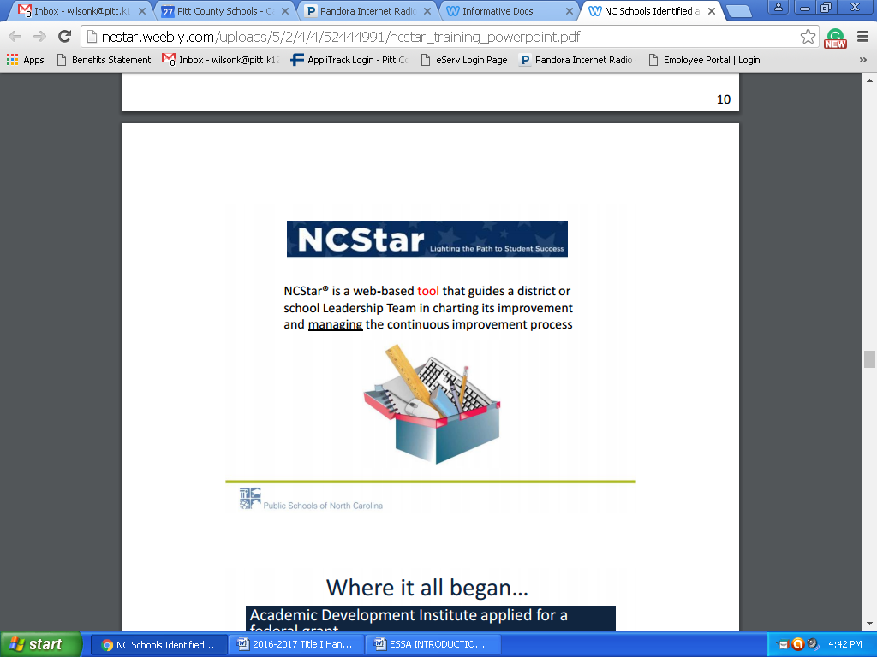

**\*All Low Performing, Priority and Focus must complete**

**NCStar (Assess 12 Indicators)**

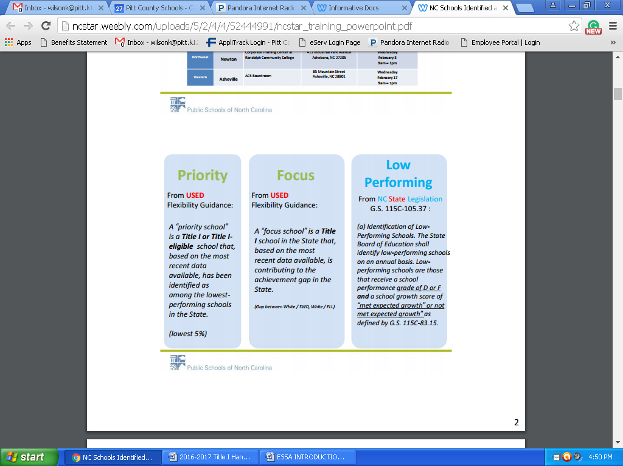

**TSI**

**CSI**

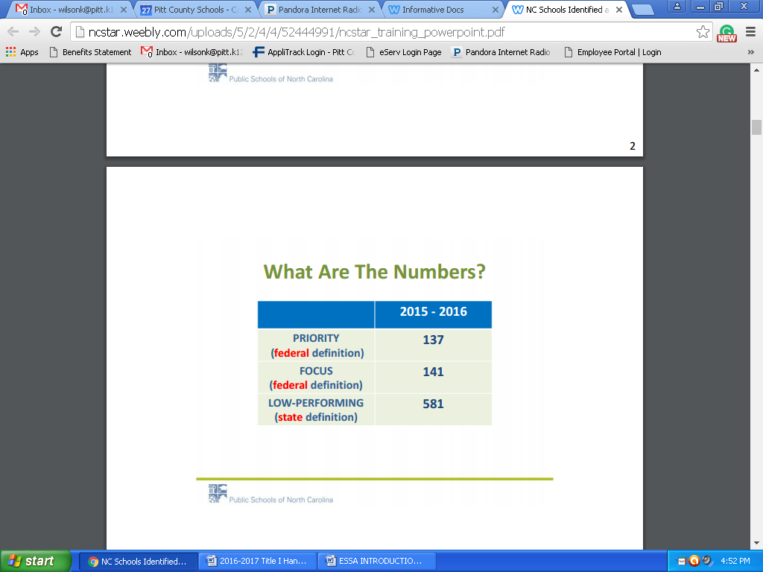

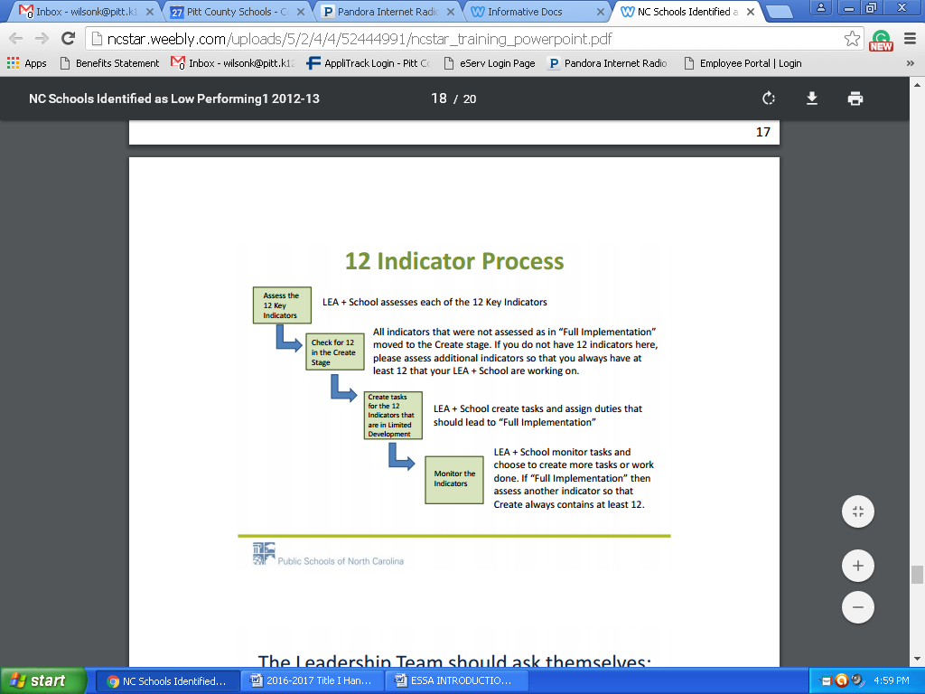

**The 12 Key Indicators**

**• CSI and TSI schools will have to assess at least the following Indicators:**

• The LEA has an LEA Support & Improvement team

• The LEA selects and hires qualified principals with the necessary competencies to be change leaders.

• A Leadership Team consisting of the principal, teachers who lead the Instructional Teams, and other key professional staff meets regularly (twice a month or more for an hour each meeting) to review implementation of effective practice.

• The principal monitors curriculum and classroom instruction regularly and provides timely, clear, constructive feedback to teachers.

• The LEA/School regularly looks at school performance data and aggregated classroom observation data and uses the data to make decisions about school improvement and professional development needs.

• The LEA/School monitors progress of the extended learning time programs and strategies being implemented, and uses data to inform modifications.

• The school has established a team structure among teachers with specific duties and time for instructional planning

• Instructional Teams develop standards-aligned units of instruction for each subject and grade level.

• The school implements a tiered instructional system that allows teachers to deliver evidence-based instruction aligned with the individual needs of student across all tiers.

• The LEA/School has established a system of procedures and protocols for recruiting, evaluating, rewarding, and replacing staff.

• All teachers are attentive to students’ emotional states, guide students in managing their emotions, and arrange for supports and interventions when necessary.

• The school regularly communicates with parents (families) about its expectations of them and the importance of the curriculum of the home (what parents can do at home to support their children’s learning).

|  |  |  |  |  |  |  |  |
| --- | --- | --- | --- | --- | --- | --- | --- |
| **Code** | **School** | **T1** | **Grade** | **Principal** | **Phone** | **Fax** | **Email** |
| 304 | Ayden Elementary | SW | PK-5 | Michael Casey | 746-2121 | 746-6470 | caseym@pitt.k12.nc.us |
| 308 | Ayden Middle |  | 6-8 | Marieka Harrison | 746-3672 | 746-9923 | harrism7@pitt.k12.nc.us |
| 310 | Belvoir | SW | PK-5 | Deirdre Ingram | 752-6365 | 752-5008 | ingramd[@pitt.k12.nc.us](mailto:coxc@pitt.k12.nc.us) |
| 320 | Bethel | SW | PK-8 | Leigh Ann Swinson | 825-3801 | 825-1203 | swinsol@pitt.k12.nc.us |
| 324 | C.M. Eppes | SW | 6-8 | Kim Harris | 757-2160 | 757-2163 | harrisk@pitt.k12.nc.us |
| 330 | Creekside | SW | PK-5 | Yolanda Williams | 353-5253 | 353-8107 | williay@pitt.k12.nc.us |
| 500 | PCS Early College High School |  | 9-12 | Wynn Whittington | 493-7821 | 752-0147 | whittiw@pitt.k12.nc.us |
| 336 | Eastern | SW | K-5 | Robert Johnson | 758-4813 | 758-7508 | johnsor@pitt.k12.nc.us |
| 337 | E.B. Aycock |  | 337 | Don Marr | 756-4181 | 756-2408 | marrd@pitt.k12.nc.us |
| 338 | Elmhurst | SW | K-5 | Daniale Stancil | 756-0180 | 756-0513 | stancid@pitt.k12.nc.us |
| 334 | Falkland | SW | K-5 | Diana Denham | 752-7820 | 752-3017 | denhamd@pitt.k12.nc.us |
| 340 | Farmville Middle |  | 6-8 | Jeremiah Miller | 753-2116 | 753-7995 | millerj1@pitt.k12.nc.us |
| 352 | Grifton | SW | PK-8 | Megan Newman | 524-5141 | 524-4505 | newmanm1[@pitt.k12.nc.us](mailto:Sandersw@pitt.k12.nc.us) |
| 358 | G.R. Whitfield | SW | PK-8 | Ashley Wheeler | 752-6614 | 752-7484 | wheelea@pitt.k12.nc.us |
| 360 | H.B. Sugg | SW | PK-2 | Allison Setser | 753-2671 | 753-7997 | setsera[@pitt.k12.nc.us](mailto:SmithN@pitt.k12.nc.us) |
| 501 | Innovation Early College High School |  | 9-12 | Jennifer James | 737-3860 | 737-0232 | jamesj@pitt.k12.nc.us |
| 368 | Lakeforest | SW | PK-5 | Anthony Perkins | 756-3941 | 756-3946 | perkina1@pitt.k12.nc.us |
| 375 | Northwest | SW | PK-5 | Sara English | 752-6329 | 752-6906 | engliss1@pitt.k12.nc.us |
| 376 | Pactolus | SW | PK-8 | Taylor Matkins | 752-6941 | 758-5817 | matkint pitt.k12.nc.us |
| 379 | Ridgewood | SW | K-5 | Leslie Hayes | 355-7879 | 355-3349 | hayesl@pitt.k12.nc.us |
| 386 | Sam D. Bundy | SW | 3-5 | Allison Setser | 753-2013 | 753-2812 | setsera[@pitt.k12.nc.us](mailto:jesterj@pitt.k12.nc.us) |
| 390 | South Greenville | SW | PK-5 | Allison Covington | 756-7004 | 756-3285 | covinga@pitt.k12.nc.us |
| 396 | Stokes | SW | K-8 | Sarah Ambrose | 752-6907 | 752-2956 | ambross@pitt.k12.nc.us |
| 380 | W.H. Robinson | SW | K-5 | LaVetta Roundtree | 756-3707 | 756-5072 | roundtl@pitt.k12.nc.us |
| 400 | Wahl-Coates | SW | PK-5 | Tracy Davenport | 752-2514 | 758-6205 | davenportt1@pitt.k12.nc.us |
| 402 | Wellcome | SW | 6-8 | Keith Neal | 752-5938 | 752-1685 | nealk@pitt.k12.nc.us |

**2022-2023 Title I Schools**

19

**SCHOOL IMPROVEMENT**



**Brief Highlights of the Every Student Succeeds Act (ESSA)**

*The President of the United States signed the Every Student Succeeds Act (ESSA) bill into law on December 10, 2015. The Elementary and Secondary Education Act (ESEA) was eight years overdue for reauthorization, and the ESSA is a critical step forward. Here are some (but not all) aspects of the new law:*

**General**

* It places many limitations on the authority of the US Secretary of Education and this includes the inability to require additions or deletions to a state’s academic content standards or to prescribe specific goals of progress, specific assessments, weights of measures or indicators, etc.
* The U.S. Department of Education (USED) will still need to issue regulations but they cannot add new requirements that go beyond what is required in the law.
* All current ESEA Flexibility Waivers will be null and void as of August 1, 2016. However, any schools currently identified as priority and focus schools must be maintained for the 2016-17 school year.

**State Plan**

* There currently is no timeline established for when the new regulations will be issued or by when and how states will submit their plans to the USED.
* It requires involvement of various stakeholders including timely and meaningful consultation with the governor in the development of the state’s plan. The governor must be given 30 days to sign the plan, but it can be submitted to the USED after the 30 days even if the governor does not sign it.
* Implementation of new state plans (once approved by the USED) will start with the 2017-18 school year.

**Assessments, Accountability and Reporting**

* It maintains annual assessments in grades 3-8 and high school.
* It reaffirms that states are in control of their standards (which must be challenging) and assessments.
* It sets parameters for a state’s accountability systems, but gives each state the flexibility to design a school accountability system that best meet the needs of the students in the state. This will include the issue of “n-size” for subgroup accountability.
* It eliminates the phrase “adequate yearly progress” (AYP).
* It maintains a 1% cap on students with the most significant cognitive disabilities, but applies the cap to the number of these students taking alternate assessments and not to capping the percentages of these students being deemed proficient for accountability purposes as under the former law. If an LEA exceeds the 1% cap, it will have to justify it to the state education agency.
* It provides for innovative assessment pilots at the state level so states can research new and improved methods of measuring student progress from year to year. Up to seven (7) states may be selected but that number could increase over time. It will be up to the Secretary of Education to determine the application process and timeline for submission to be one of the pilot states.

NC Department of Public Instruction January 28, 2016

**Brief Highlights of the Every Student Succeeds Act (ESSA) Cont**.

* The accountability plans must include goals for academic indicators (improved academic achievement on State assessments, a measure of student growth or other statewide academic indicator for elementary and middle schools, graduation rates for high schools, and progress in achieving proficiency for English Learners) and a measure of school quality and student success (examples include student and educator engagement, access and completion of advanced coursework, postsecondary readiness, school climate and safety). Participation rates on the assessments must also be included in the plan.
* Students with limited English proficiency will be allowed to remain in the English Learner (EL) subgroup for up to four (4) years after exiting the EL classification. This prevents the EL subgroup from always having students with the lowest levels of English proficiency for accountability purposes.
* It maintains many reporting requirements including the State Report Card (SRC). SRC data are expanded to include information on homeless students, foster youth, and students of parents on active duty in the military, information on acquisition of English proficiency by English Learners and professional qualifications of teachers.

**Teacher Quality**

* It gives states the flexibility to work with local stakeholders to determine how educators should be evaluated and supported each year.

**District and School Interventions**

* There is no set of required federal sanctions, but interventions used in schools needing assistance and support must be **evidence-based.**
* States will have to identify, at a minimum, the lowest 5% of Title I schools and high schools with graduation rates lower than 67%. These are the schools that are part of Comprehensive Support and Improvement (CSI).
* LEAs must develop and implement CSI plans for lowest-performing schools – State must approve plans o States also have to identify schools with consistently underperforming subgroups for Targeted Support and Improvement (TSI).

**Funding and Formulas**

* It eliminates the federal School Improvement Grants (SIG), but allows states to reserve 7% of Title I funds to make grants available to low-performing schools.
* A portion of State Assessment grants will be made available as a separate allocation to states to conduct audits of state or local assessments as a way to reduce redundant assessments. It combines some 50 programs into a big block grant under Title IV.
* Finally, it authorizes a Preschool Development Grants Program through the Department of Health and Human Services.

NC Department of Public Instruction January 28, 2016

NC Department of Public Instruction January 28, 2016

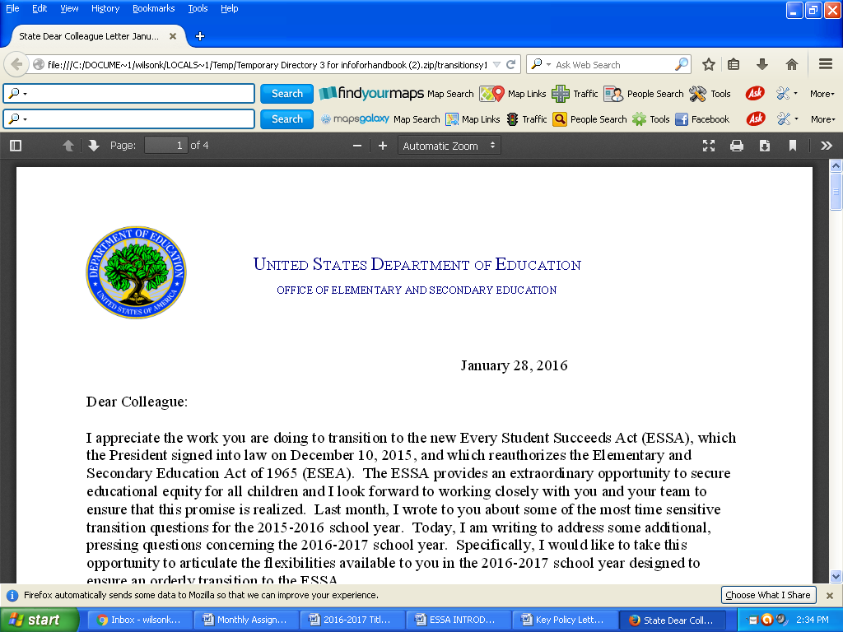

January 13, 2017

Dear Colleague:

I want to begin by thanking you for the substantial work you have done—and that you continue to do— to enable a successful transition to the Every Student Succeeds Act (ESSA), which reauthorized the Elementary and Secondary Education Act of 1965 (ESEA). The ESSA provides a significant opportunity for States and school districts to develop and implement new plans to help secure educational equity for all children, close achievement gaps, and continue making progress in supporting educators, students, and their families.

In [November 2016,](http://www2.ed.gov/policy/elsec/leg/essa/essadcl-accountability-plus-112916.pdf) the U.S. Department of Education (Department) released [final regulations re](https://www.federalregister.gov/documents/2016/11/29/2016-27985/elementary-and-secondary-education-act-of-1965-as-amended-by-the-every-student-succeeds)garding statewide accountability systems and data reporting under Title I of the ESEA and the preparation of State plans, including consolidated State plans for ESEA State formula grant programs. In those regulations, in response to overwhelming requests from States and other stakeholders as well as Members of Congress, the Department clarified that a State may delay identification of schools for comprehensive support and improvement, as well as schools with low-performing subgroups for

targeted support and improvement, until the beginning of the 2018–2019 school year and may delay identification of schools with consistently underperforming subgroups for targeted support and improvement until the beginning of the 2019–2020 school year. In the November 29, 2016, [Dear](https://www2.ed.gov/policy/elsec/leg/essa/essadcl-accountability-plus-112916.pdf) [Colleague Letter on](https://www2.ed.gov/policy/elsec/leg/essa/essadcl-accountability-plus-112916.pdf) ESSA State Plans, the Department revised the deadlines for State plan submissions to include application windows in April 2017 and September 2017. Consequently, we anticipate that many States will not have their State plans, including their methodologies for identifying schools for comprehensive or targeted support and improvement, approved prior to the start of the 2017–2018 school year and, therefore, will not be ready to fully implement their new accountability systems by the beginning of the 2017–2018 school year. The purpose of this letter is to address some key questions arising from this delayed implementation timeline.

***Supporting Low-Performing Schools***

Consistent with the provisions of the ESSA that authorize the Department to ensure an orderly transition to the new law, each State must continue to provide supports and interventions in the State’s low- performing schools in the 2017–2018 school year in the same manner in which it supported and intervened in those schools in the 2016–2017 school year.

To identify its low-performing schools in the 2017–2018 school year:

A State that operated under ESEA flexibility prior to the termination of that flexibility on August

1, 2016, may either: (1) continue to serve its existing priority and focus schools, except that the State may remove from the list of priority and focus schools any school that has met the State’s exit criteria; or (2) refresh its list using its existing methodology in place prior to the start of the

2017–2018 school year.

400 MARYLAND AVE. SW, WASHINGTON, DC 20202 [www.ed.gov](http://www.ed.gov/)

*The Department of Education’s mission is to promote student achievement and preparation for global competitiveness by fostering educational excellence and ensuring equal access*

A State that did not operate under ESEA flexibility prior to August 1, 2016, must continue to support and intervene in schools or local educational agencies (LEAs) that were identified in the

2016–2017 school year by the State as in need of improvement, corrective action, or restructuring under the ESEA, as reauthorized by the No Child Left Behind Act of 2001

(NCLB), except that the State may remove from the list any school that has met State-determined criteria to no longer be identified for improvement, corrective action, or restructuring.

If a State receives approval of its new State plan under the ESSA in time to identify schools for comprehensive or targeted support and improvement during the 2017–2018 school year, it may choose

to begin implementation of improvement plans in any newly identified schools, rather than wait until the beginning of the 2018–2019 school year. The Department will work with such a State to ensure that schools identified for comprehensive or targeted support and improvement and their LEAs begin developing school improvement plans in a timely manner consistent with the requirements of the ESEA, as amended by the ESSA.

***School Improvement Resources***

The ESEA, as amended by the ESSA, also requires each State to reserve funds for LEAs to support schools that are identified by the State for comprehensive or targeted support and improvement under its new accountability system. More specifically, under section 1003(a) of the ESEA, as amended by the ESSA, each State must reserve from its annual Title I, Part A allocation the greater of (1) seven percent of that allocation, or (2) the sum of the amount reserved for fiscal year 2016 under section 1003(a) of the ESEA, as amended by NCLB, and the amount received for fiscal year 2016 for School Improvement Grants (SIG) under section 1003(g) of the ESEA, as amended by NCLB.

In fiscal year 2017 (*i.e.*, for use in the 2017–2018 school year), each State must allocate funds under section 1003(a) of the ESEA, as amended by the ESSA, by competition or by formula to LEAs with low-performing schools (identified consistent with the “Supporting Low-Performing Schools” section above). In addition, a State may choose to use the funds that it reserves in fiscal year 2017 to support full implementation of SIG awards initially made with prior-year funds, as described in the Department’s [letter to](https://www2.ed.gov/programs/sif/sigdirapplicationltr3292016.pdf) SIG Directors from March 2016.

Finally, we remind you that, consistent with section 421(b) of the General Education Provisions Act, a State that does not need all of the school improvement funds it reserves in fiscal year 2017 to serve identified schools in the 2017–2018 school year may carry over any remaining funds for use in the

2018–2019 school year, once it has an approved State plan and identified schools for comprehensive and targeted support and improvement. In particular, we encourage a State choosing to exit schools from improvement status in the 2017–2018 school year—without refreshing its lists of low-performing schools—to consider carrying over a portion of its fiscal year 2017 funds under section 1003(a) of the ESEA, as amended by the ESSA, for use in the 2018–2019 school year in order to support its first cohort of schools identified under the ESSA, when LEAs and schools will require additional support from the State to implement the new school improvement provisions, including evidenced-based interventions, required by the ESSA. We also note that LEAs may use their fiscal 2017 funds under section 1003(a) on district-level activities intended to support schools that receive school improvement funds, which an

LEA may determine is advisable given the new cohort of schools in the 2018-2019 school year. For example, an LEA may hire a district-level turnaround specialist to establish an “early warning system”

designed to identify students in identified schools who may be at risk of failing to achieve high standards or graduate, or to support implementation of evidence-based interventions in such schools.

All of the Department’s guidance related to the transition to the ESSA can be found at [http://www2.ed.gov/policy/elsec/leg/essa/index.html.](http://www2.ed.gov/policy/elsec/leg/essa/index.html) If you have any questions or need additional information, I encourage you to reach out to your Office of State Support contact at

OSS.[State[]@ed.gov](mailto:@ed.gov) (*e.g.*, OSS[.Nebraska@ed.go](mailto:Nebraska@ed.gov)v). Additionally, I encourage you to sign up to receive updates on ESSA guidance, including transition guidance, by clicking [here.](https://public.govdelivery.com/accounts/USED/subscriber/new?topic_id=USED_5)

Thank you for your ongoing commitment to improving educational outcomes for all students.

Sincerely,

/s/

Ann Whalen

Senior Advisor to the Secretary

Delegated the duties of Assistant Secretary for

Elementary and Secondary Education

cc: State Title I Directors

State SIG Directors

24

|  |  |
| --- | --- |
| **July**  **Title I School-Wide Program**  **Calendar** | **August** |
| * Submit draft ESEA parent notification, if Focus or Priority School * Store files-Keep Title I documents for 5 years * Submit POs Recommendation Forms for upcoming year needs to be done in Applitrack * Need to update Title I Plan * Catalogue Title I purchases * **Read Title I Guidelines/Procedures** * Set up meetings w/Federal Programs Director if needed * Select teachers to attend PD * Comprehensive Needs Assessment * NCSTAR | * Schools revisit School Improvement Plans * Revise School Title I Plan * Send home Parent Notification-Priority/Focus School * Select Title I Contact * Update Budget sheet with correct teacher names and changes before school starts * Catalogue Title I Purchases * Submit Focus School Plan * Submit Comprehensive Needs Assessment 2022-2023 * Leadership Team Professional Development |
| **September** | **October** |
| * Schools Conduct Annual Title I Parent Meeting * Schools Submit Principal’s Attestation * Develop Prioritized Plan * Submit budget amendment * Schools submit School Improvement Plans, if applicable * ESL Classes begin after testing (Contact LaVette Ford and ESL Contacts) * Send home letters to parents about HQ Status of teachers/TA’s (Parent’s Right to Know) * Need to update Title I Plan * Catalogue Title I purchases | * Submit copy of verification letter to Title I office of the Parents Rights to Know letter * Technical Assistance for Focus/Priority School * Set up ESL Tutorial Groups * Need to update Title I Plan * Catalogue Title I purchases * Review/Edit School Data Summary * Analysis * Focus Schools Meeting |
| **November** | **December** |
| * Need to update Title I Plan * Catalogue Title I purchases * Upload documents on website * Parent Conferences- (Compact) | * Need to update Title I Plan * Catalogue Title I purchases |
| **January** | **February** |
| * LEA Planning/Instructional Services Input * Final PO requisitions for computers * **75% of Title I funds should be spent** * Submit Semi-Annual Certification Forms * Need to update Title I Plan * Catalogue Title I purchases * Upload documents to website | * Spend Title I Funds before March 31st 2023 * Need to update Title I Plan * Catalogue Title I purchases |
| **March** | **April** |
| * Assistant Principal Meeting * Need to update Title I Plan * Catalogue Title I purchases | * Catalogue Title I purchases * Complete and return School Data and Summary Analysis-Focus Schools * Need to update Title I Plan * Catalogue Title I purchases * Schools need to notify Federal Programs of summer programs |
| **May** | **June** |
| * Title I Principal Meeting * Receive Title I Planning Allocation * Analyze parent involvement attendance * Need to update Title I Plan * Catalogue Title I purchases * Title I Inventory is due | * Annual program review * Submit Semi-Annual Certification Form * Turn in planning documents for 2023-2024 * Turn in:   -Title I Budget  -Parent Involvement Plan  -Parent Involvement Policy  -Parent Involvement Requirements  -State of Assurance  -Parent Involvement Workshops  (Dates/Times) for 2023-2024 year |

**Transportation**

**Yellow Buses/Activity Buses**

Title I will pay for transportation when it is used for after school tutoring services. If a yellow bus is used for services, the Transportation Department will invoice the school. The invoice will include all costs associated with yellow buses. The original invoice should be signed by the principal and sent to the Title I department for payment along with a purchase order and **student’s roster**.

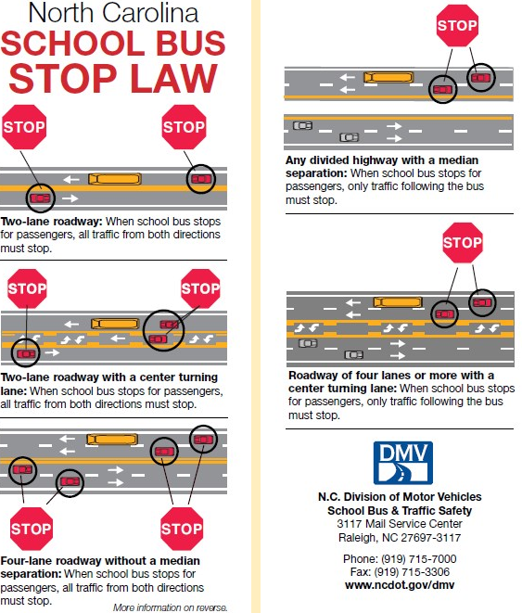

**Title I Plan/Budget**

**Information**



**Guidelines for Use of Title I Funds**

Title I schools must ensure that funds support efforts to improve performance of all students with particular attention to students who are failing, or at risk of failing to meet at minimum, the NC academic proficiency standards on state academic assessments.

1. Funds may be used to **supplement, not supplant**, other state and local resources for improving the instructional program.
2. All expenditures should be reflected in the School Improvement Plan (SIP) **and** on the Title I Prioritized School Plan, and should have a strong likelihood of impacting the instructional program in the current year. Inappropriate expenditures may require alternative funding sources.

Planning budgets are developed in the spring proceeding the implementation year based on the planning allocation provided to each school. School planning budgets are incorporated into the district application, and submitted to the NC Department of Public Instruction for review and approval. Once approved, adjustments to the budget must be approved by the local School Board and DPI.

Funds allocated during a fiscal year are to be:

1. Expended during the same time period, and with the exception of school improvement funds
2. Do not carry-over at the school level to the next year.
3. Funds from one year’s allocation may not be used to pay for activities occurring in another fiscal year.

**Recommended Expenditures:**

* Instructional Staffing
* Additional classroom teachers
* Resource teachers in core areas
* Extended time programs (before/after school, Saturday, summer) for lowest performing students and related expenses (i.e. tutor salaries, transportation)
* Pre-kindergarten program (salaries, materials, parent involvement, professional development)
* Instructional materials/supplies
* Instructional technology
* Parenting education activities and supplies
* High quality professional development activities and materials

Plan ahead and always adhere to Finance Department policies and procedures as outlined by Pitt

County Schools for all Title I funded expenditures.

**Please Note**

All Title I schools are required to complete the following documents:

1. Comprehensive Needs Assessment

2. Prioritized Plan

3. School Improvement Plan

**Title I Budget**

**A. Personnel** – As you revise your budget, think about the following:

(See Title I SalaryAllocations)

* Number of teachers paid from Title I
* Salaries of those teachers
* Consider salary exchanges (salary swap). Exchanges may only be used for teachers serving students (not facilitators, counselors, etc.) and must be exchanged with a job-alike person (classroom teacher exchanged for another classroom teacher, not Art or Music teacher).
* If you are replacing a teacher with a Title I teacher that you have swapped, please indicate that on the Interview Recommendation Form or the HR Change Form.
* Amendments to Title I plan can be done during the year. Please complete a Federal Programs “Move Money Form” when transferring Title I funds to another budget code.
* Before Interview Recommendation Forms can be processed, an update budget must be sent to Patricia Cox. If you do not send an update budget, the IF form, **will not** be approved.

**B. Instructional Supplies and Materials**

* Materials purchased with Title I funds must be directly linked to instruction, student achievement, and the Comprehensive School Plan.
* By January, 75% of the school’s Title I instructional supplies and materials amount should be spent.
* **All invoices for materials must be in the Federal Programs Office by March 31. Title I (050) funds will not be available after this date.**
* **Will be monitored by the Federal Programs Director monthly.**

**C. Use of Title I funds**

* **Use Title I funds to supplement other fund sources, not to provide district-adopted textbooks, teacher editions, or basic items that are found in classrooms as part of a new classroom equipment and supply setup.**
* **Avoid** using Title I funds for the following:
* Copier payment
* Items for teachers (selected items)
* Food **can only be used** for a Title I Parent Involvement activity. In such case, **an agenda and a dated sign-in sheet for the activity must be attached to the food invoice)**
* **Maximum amount to be spent on food is $4.50 per person.**

* Memberships in organizations
* Payment for professional development activities not identified in Comprehensive Plan or included as part of a district initiative
* Phone payment (unless for Parent Involvement or at-risk activities)
* Postage (Not to pay for school’s basic operational postage; can pay postage for

at-risk student activities or designated Parent Involvement plan activities)

* Reminder: Items purchased with Title I funds should be for the targeted grade levels: K-5, K-8 or 6-8 (student list should be available for review).
* In order to keep the Federal Programs Office records aligned with the appropriate use of Title I funds and the strategies in the Comprehensive Plan, the following process will take place. If we receive a purchase order or memo that is questionable for payment with Title I funds, we will send an email and ask you to provide justification for the purchase and return it to the Title I office **(Pink Notice).**

**D. Prior Approvals/Purchase Orders**

* All prior approvals and purchase orders for Title I funds (050) must come **FIRST** to the Federal Programs Office.
* Purchase Orders for payment and/or reimbursement should include the following information:
* Name and address of person, school, or business to which payment is due
* Budget Code Number
* Memo identifying item and/or title and date of event (if applicable)
* Name of person(s) (if Purchase Order is for workshop or staff development session)
* Principal signature

**E. Work Verification Sheets**

* You will review and sign a semi-annual certification of employees paid from

Title I funds in January and June of each year.

* If a staff member who works in your school and at no other school is paid partially from Title I funds and partially from a state or local fund source, you may still certify that this person works 100% in your school wide program.
* If a staff member works only part-time at your school and at no other school, you may certify that this person works 100% in your school wide program.
* If a staff member works **at your school and another school,** please **contact me** to see if that staff member should complete a Personnel Activity Report (PAR) each month.

**F. Move Money Form**

* When updating budget, remember to use a Move Money Form and send updated Budget Plan to Patricia Cox.

Title I Allowable and Non-Allowable Cost Reference Guide Examples

|  |  |  |
| --- | --- | --- |
| CATEGORY OF ACTIVITY | ALLOWABLE | NON-ALLOWABLE |
| Student Incentives | * Have clearly established school award criteria in place * Are reasonable and necessary to carry out Title I program * Do not exceed 1% of school’s Title I allocation for the school year * Are supplemental in nature * Are awarded for academic progress in core subjects, attendance, and/or behavior * Non-monetary rewards of nominal value * Books * Instructional supplies/materials * Plaques | * Cash awards * Gift cards * Incentives which advertise a product or brand * Incentives used as an incentive to participate in a program |
| Parent Involvement | * Parent Involvement coordinators and liaisons * Assistance and training for parents * Parent literacy and education * Assistance for parents to work with their children * Parent volunteers in classrooms * Training for school staff to increase collaboration with parents |  |
| Homeless Students | * Items of clothing, especially those necessary to meet a school's dress code * Clothing and shoes necessary for participation in physical education classes | * Rent or temporary lodgings * Class ring * Cost of drivers’ test fees * Extra-curricular activity fees |

Title I Allowable and Non-Allowable Cost Reference Guide Examples

|  |  |  |
| --- | --- | --- |
| CATEGORY OF ACTIVITY | ALLOWABLE | NON-ALLOWABLE |
| Homeless Students Cont. | * Student fees that are necessary to participate in the general education program * Personal school supplies such as backpacks and notebooks * The acquisition of birth certificates * Immunizations * Food * Medical and dental services * Eyeglasses and hearing aids * Counseling services related to homeless issues that are impeding learning * Outreach services * Extended learning time (before and after school, Saturday, summer) * Tutoring services, especially in shelters or other locations where homeless students are residing * Parental Involvement * Fees for AP (for students ineligible for the waiver) and IB testing * Fees for SAT/ACT testing (for students ineligible for the waiver * GED testing |  |
| Staff Salaries | * Hiring additional teachers to reduce class size |  |

Title I Allowable and Non-Allowable Cost Reference Guide Examples

|  |  |  |
| --- | --- | --- |
| CATEGORY OF ACTIVITY | ALLOWABLE | NON-ALLOWABLE |
| Staff Salaries Cont. | * Hiring additional teachers to serve as reading/math interventionists * Substitute pay for these teachers when absent * Supplemental instructional, curriculum, and data coaches * Supplemental guidance counselors can be hired to provide supplemental guidance services * Supplemental paraprofessionals to support instruction | * Using Title I funds to pay for teacher, guidance counselor, or paraprofessional whose salary would normally be paid for with General Funds |
| Teacher Incentives | * Financial incentives and rewards may be provided to teachers I Title I schools identified as Newly Identified, Continuing School Improvement, Corrective Action, Plan to Restructure, and/or Restructure * The purpose of these financial incentives and rewards must be to attract and retain qualified and effective teachers in those schools. | * A district may not reserve more than 5% of its Title I, Part A allocation for these financial incentives and rewards |
| Professional Development | * Conferences including registration, room, food, travel * Consultants * Stipends and/or substitute pay for educators attending professional development activities * Professional development supplies and materials | * Professional development outside of education * Professional development for which the District is using General funds to pay costs for Non-Title I schools |

Title I Allowable and Non-Allowable Cost Reference Guide Examples

|  |  |  |
| --- | --- | --- |
| CATEGORY OF ACTIVITY | ALLOWABLE | NON-ALLOWABLE |
| Substitute Teachers | * Funds used to pay substitutes for Title I funded staff at the school level that is budgeted for in the school’s plan * Funds to pay substitutes to allow certified teachers in Title I schools to attend professional development as provided for in the school plan | * Using Title I funds to pay for substitute teachers not provided for in the approved school plan * Using Title I funds to pay for substitute teachers instead of using other funds given to the schools to pay for substitutes (Title I funds should be supplemental) |
| Technology | * Computer hardware to support student instruction, such as laptops, Smart boards, mobile computer laptops * Computer software to support student instruction * Technology supplies such as flash drives, paper, ink | * Hardware or software for which the district is using state or local funds to pay for in non-Title I schools * Technology that is not tied to an allowable activity, program or intervention |
| Instruction | * Funds used to increase the participation of low –achieving students in advance coursework * Summer school classes for low-achieving students * Before, after, and/or Saturday school tutoring * Development and use of formative and interim assessments to tract progress of low-achieving students * Before, after and/or Saturday school tutoring | * Instructional costs for which the District is using General funds to pay costs for non-Title I schools * Field trips which have no clear ties to classroom instruction |
| Instruction Cont. | * Development and use of formative and interim assessments to track progress of low-achieving students |  | |

|  |  |  |  |  |  |  |  |  |  |  |  |  |  |  |  |  |  |
| --- | --- | --- | --- | --- | --- | --- | --- | --- | --- | --- | --- | --- | --- | --- | --- | --- | --- |
|  | **Title I Funding** | | | | | | | | | | | | | | | | |
|  | Instructional Supplies & Materials | Contracted Services | Services | Smartboards | Instructional Software | Capitalized Computer-  Non Equipment | Parent Involvement | Teachers | Assistants | Tutors (After school/During) | Substitute Pay | Professional Development | Bus Driver Salary | Transportation |
| Fund 050 | **X** | **X** | **X** | **X** | **X** | **X** | **X** | **X** | **X** | **X** | **X** | **X** | **X** | **X** |

|  |  |  |  |
| --- | --- | --- | --- |
| **2022-2023 Title 1 (050) Allocation Summary** | | | |
| *\*Calculations enter themselves based on your allocation worksheet\** | | | |
| **School:** | **SAMPLE** | | |
|  | **2022-2023 Allocation** | | $114,196.65 |
|  | **2022-2023 Parent Involvement Allocation** | | $2,690.59 |
|  |  |  |  |
|  | **Available Funds 2022-2023** | | **$116,887.24** |
|  |  |  |  |
|  |  |  |  |
|  | **Special Instructional 5330** | | **$0.00** |
|  |  | **Classroom Teacher** | $0.00 |
|  |  | **Classified Employee** | $0.00 |
|  |  | **Remediation Teacher** | $0.00 |
|  |  | **Substitute Teachers - Regular Teacher** | $0.00 |
|  |  | **Substitute Teachers - Staff Development** | $0.00 |
|  |  | **Contracted Services** | $0.00 |
|  |  | **Instructional Supplies** | $0.00 |
|  |  | **Non-Capitalized Instructional Equipment** | $0.00 |
|  |  | **Non-Capitalized Computer Equipment** | $0.00 |
|  |  | **Capitalized Equipment** | $0.00 |
|  |  | **Computer Software** | $0.00 |
|  |  | **Professional Development** | $0.00 |
|  |  | **Teacher Incentive** | $0.00 |
|  | **After School & Saturday 5351 & 5353** | | **$0.00** |
|  |  | **PCS Employee Contract Pay** | $0.00 |
|  |  | **Instructional Supplies** | $0.00 |
|  |  | **Bus Transportation Drivers** | $0.00 |
|  |  | **Transportation Expense** | $0.00 |
|  | **Summer School 5354** | | **$0.00** |
|  |  | **PCS Employee Contract Pay** | $0.00 |
|  |  | **Instructional Supplies** | $0.00 |
|  |  | **Transportation Expense** | $0.00 |
|  | **Parent Involvement 5880** | | **$0.00** |
|  |  | **Supplies Expense** | $0.00 |
|  |  | **Food Expense** | $0.00 |
|  | **Total Allocated Expenditures** | | **$0.00** |
|  | **Remaining Unallocated Funds** | | **$116,887.24** |

**Purchase Orders/Invoices/Reimbursement**



**The Process of Submitting a**

**Purchase Order using Title I Funds**

1. Submit the purchase order to Federal Programs.

**FYI:**  Before submitting the purchase order, tear off the golden rod copy for your records.

1. Once the PO has been submitted to Federal Programs, the Title I Director will approval and send to the Federal Bookkeeper.
2. The Federal Bookkeeper will look over the PO and send it to the Asst. Superintendent of Educational Programs and Services for approval.
3. Once approved by the ASEPS, it is sent back to the Federal Bookkeeper.
4. The Federal Bookkeeper enters the information into AS400.
5. Once it is assigned a PO number, the Federal Bookkeeper will send **only** the pink and blue copy back to the school.
6. Once the material is received, complete the information at the bottom of the pink and blue copies of the PO - invoice date, invoice number, and amount and sign it at "received by".  Attach a copy of the invoice to each copy -blue and pink.  Send the completed pink copy with invoice to Federal Bookkeeper, Sonja Warren.  Keep the blue copy with the invoice copy for your files.

**FYI:**The blue copy will provide you with the PO # if you need to look it up, and will also provide you with the invoices.

When completing a purchase order always add the total cost of all the items and write that amount in the Gross Total.  If there is any shipping charges that would be listed next in the line item "Shipping Charges".  Always fill in the "Subtotal" line item.  The sales tax is computed on the amount of the "Subtotal" which is the Gross Total plus any shipping minus any discount given.  We are required by the State of North Carolina to pay sales tax on shipping, it is NOT exempt.  In addition, you will enter the current rate of sales tax for Pitt County on the purchase order, no matter where you are ordering the material from.  If you have a proposal or quote and the company does not charge sales tax, we are still required to pay the sales tax.  Therefore, sales tax should be on all merchandise ordered.

Note:

**Please keep in mind that the Federal Bookkeeper has to request the money from the state which takes 5 working days.   We will not be able to pay for any orders not approved and processed through the Federal Programs Office.**

### Title I Purchasing Guidelines

In accordance to the ESEA Waiver formerly known as NCLB Act of 2001 (sec. 101), Title I funds are provided to improve the academic achievement of disadvantaged students.

* All Title I purchase requests need to be documented in the plan. Purchase orders must include budget code (from budget sheet) as well as where money was allotted for items. Purchase requests not in plan will not be approved. All Title I Purchase Orders need to be sent to the Federal Programs Office located at Moye Annex. Do not send Purchase Orders to Sonja Warren at Central Office without Federal Programs Director signature.
* Purchase orders must support school goals with an instructional purpose. Title I funds should be used to purchase instructional materials such as leveled books, manipulatives, technology programs or workbooks. Paper should be purchased with local/state instructional funds first. When those funds have been depleted, Title I funds can be used. Parent Involvement supplies can be purchased with Title I funds (materials for workshops or paper for newsletters, handouts for meetings). Refer to guidelines for reimbursement for Parent Involvement Activities.
* Incomplete purchase orders with missing information, or hard to read purchase orders will be returned to you with a Purchase Order Review sheet (pink) and explanation.
* If you have more than 1 error on the purchase order or other forms, please re-do the form. If you are making a correction, strikethrough once and initial beside any corrections.
  + Ex: My name is ~~Jnae~~ Doe
* Purchase Orders or any other forms being submitted to Federal Program with whiteout WILL NOT be accepted.
* When filling out a purchase order or forms, please use blue or black ink.
* When purchase orders and contracts are complete and meet the guidelines, they will be processed for payment.
* *Gift cards* cannot be used as a parent incentive for participation. Due to federal audits, commercial gift cards are not eligible expenses.
* Schools will still be able to purchase books from book fairs and provide vouchers for parents. School uniform vouchers are acceptable expenses. Other acceptable items are: purchased door prizes, book vouchers, instructional materials, and food items (Use form provided by Federal Programs).
* You can no longer use funds to purchase door prizes.
* Whoever picks up the supplies/materials/food, etc for the workshop needs to sign the receipt.
* Parents need to sign the “Parent Incentive Sheet” for any incentive received from the school (Use form provided by Federal Programs).
* **To be reimbursed—paperwork needs to be submitted within the same month!**
* To be reimbursed for Title I Workshops, at least 5 parents need to be in attendance and on the sign-in sheet (Use form provided by Federal Programs for Sign-In Sheet).
* There is a 25-box limit on ordering paper to support instructional programs per year.
* Please complete a Computer Requisition Form (see Forms) if you plan to use Title I funds to purchase technology or computer equipment for instructional purposes. This information is required by our Finance Department to develop/amend budget for the fiscal year.
* Each item that is purchased for less than $3,000 per unit (including shipping/handling and taxes) needs to be purchased from one of the budget 461, 462.
* When purchasing smart board bulbs use the budget code for supplies, use code 411.
* *Each item that is purchased for more than $3,000 per unit (including shipping/handling and taxes) needs to be purchased from one of the budget 541, or 542.*
* If item is stolen, broken, or lost you will need to complete a Disposition Form (see Forms).

*Do not discard item(s), until you hear back from the Federal Programs Office.

**Things to Remember**

**Purchase Orders**

* Make sure you keep goldenrod copy before sending PO to Federal Programs.
* **Do Not** date the PO. This will be done at the Central Office.
* **Do Not** put a vendor # on the PO – once obligated the computer assigns the vendor number.
* Be sure and sub-total the PO and fill in the appropriate box, if using the most recently printed POs.
* **Do Not** put the total of the PO in the red box. Some old copies of POs have “Grand Total” printed here. The most recently printed one say “Total Invoices”. This box is to be filled in when completing PO for payment.
* Make sure “Vendor” is whom we are to write the check to. Example, if we are reimbursing a school for books purchased at Barnes and Noble, the vendor would be the school, **NOT** Barnes and Noble.

**Invoices and Payments**

* If sending an invoice for direct payment, that is, for reimbursement, hotel, registrations, etc., be sure to sign and date the PO at “Received By”. PO will be sent back to you if not signed and dated.
* **Please make sure quotes/invoices are current and up-to-date. Quotes/Invoices that are expired will not be accepted.**
* **When submitting a purchase order for payment, please attach the actual invoice and NOT the quote.**
* **Principals need to sign the invoice.**
* **Please submit pink copy of the purchase order and invoice to Sonja Warren, Federal Bookkeeper, and not Federal Programs.**
* Send all items for direct payment to the **Federal Programs Office** at Central Office Annex to be approved by the Title 1 Director. If you send them directly to Sonja Warren, she will still have to send them to the Federal Programs Office before payment can be made. This causes unnecessary delays in the process.
* is a purchase order that needs to be processed faster, please walk the purchase order to the Federal Program Office.
* Please keep in mind that the Federal Bookkeeper has to request the money from the state which takes 5 working days
* When sending invoices, reimbursements, bills, or anything to be paid from Title 1, please be aware that it will not be paid until the money to cover the expenditure can be deposited into the State Treasury Bank Account. When money is deposited, it must be spent within 3 days. There can be no excess money in the Federal account after 3 days. Whenthe bills are received, the money will be requested and the checks will not be written until the money is deposited. So remember this when sending in workshop registrations and hotel reservations.

Expense Reimbursement

* The following documents are needed when going on a Title I Workshop, Out of County/State:
  + Estimate of Travel (Submitted prior to workshop)
  + Copy of Registration Form (may be submitted prior to workshop)
  + Agenda (upon returning)
  + Expense Reimbursement Form (completed upon returning)
  + Mileage (To/From Destination-Found using MapQuest), if applicable

*Please keep in mind not to go over allocated amount for meals. If the amount goes over the allocated amount, you will only be reimbursed the amount give on the reimbursement form.

*The mileage rate for the district has changed to 62.5

*Federal Programs does not reimburse for tips. We can only reimburse the price of the meal. With that in mind, the receipts need to show the “actual” meal, not just the price. We cannot accept the credit card swiped w/tip.

* Receipts need to be itemized, showing meals purchased. Receipts without meals shown WILL NOT be accepted.
* Federal Programs DOES NOT pay for alcoholic beverages, therefore alcoholic beverages SHOULD NOT be listed on the receipt that you will be using to get reimbursed.

***Travel reimbursement must include signed receipts starting August 1, 2014. **



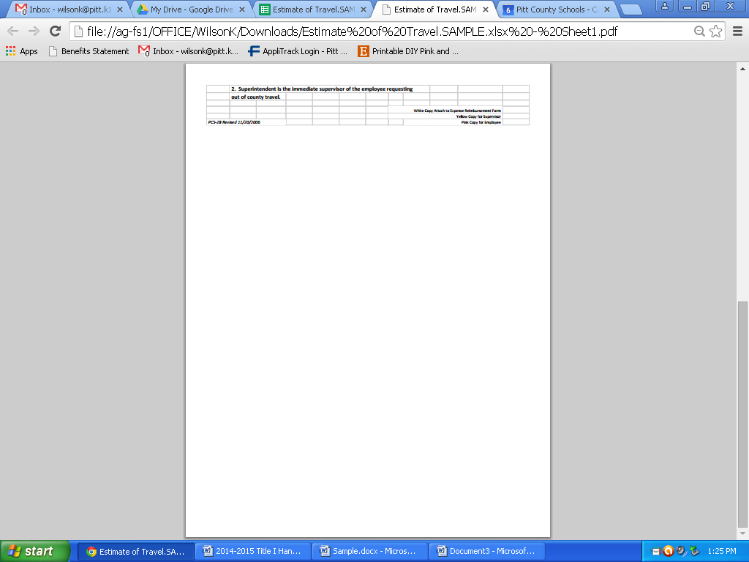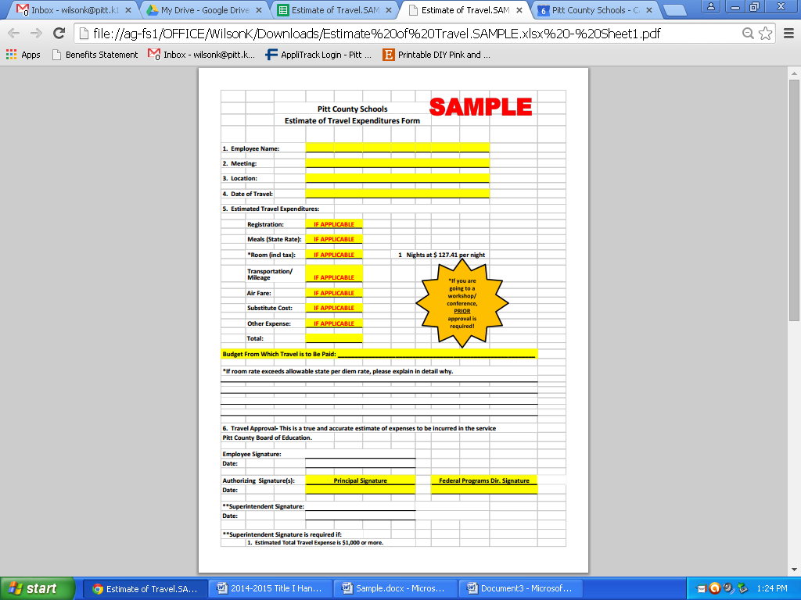

49

|  |  |  |  |  |  |  |  |  |  |  |  |  |  |  |  |  |  |  |  |  |  |  |  |  |  |  |  |  |  |  |  |  |  |  |
| --- | --- | --- | --- | --- | --- | --- | --- | --- | --- | --- | --- | --- | --- | --- | --- | --- | --- | --- | --- | --- | --- | --- | --- | --- | --- | --- | --- | --- | --- | --- | --- | --- | --- | --- |
|  |  |  | **PITT COUNTY BOARD OF EDUCATION PURCHASE ORDER AND RECEIVING REPORT** | | | | | | | | | | | | | | | |  | |  | |  | |  | |  | |  | |  | | | |
|  |  |  |  |  |  | |  | |  | |  | |  | |  | | **CENTRAL OFFICE USE ONLY** | | | | | | | | | | | | | | | | |
| CHARGE TO: | |  |  |  |  | |  | |  | |  | |  | |  | | Purchase  Order No._________________________________ | | | | | | | | | | | | | | | | |
| Pitt County Schools | | | |  |  | |  | |  | |  | |  | | Date: ____________________________________ | | | | | | | | | | | | | | | | | | |
| 1717 West Fifth Street | | | |  |  | |  | |  | |  | |  | |  | |  | |  | | |  | |  | |  | |  | |  | |  | |
| Greenville, NC 27834 | | | |  |  | |  | |  | |  | |  | |  | |  | |  | | |  | |  | |  | |  | |  | |  | |
|  |  |  |  |  |  | | INVOICE IN DUPLICATE | | | | | | | |  | |  | |  | | |  | |  | |  | |  | |  | |  | |
| **CENTRAL OFFICE USE ONLY** | | | |  |  | |  | |  | |  | |  | |  | |  | |  | | |  | |  | |  | |  | |  | |  | |
| VENDOR NO. | |  |  |  |  | |  | |  | |  | | | |  | |  | |  | | |  | |  | |  | |  | |  | |  |
|  |  |  |  |  |  | |  | |  | |  | |  | |  | | |  | |  | |  | |  | |  | |  |
|  |  |  |  |  |  | |  | |  | |  | |  | |  | |  | |  | | |  | |  | |  | |  | |  | |  |
|  |  |  |  |  |  | |  | |  | | **Attention: First and Last Name** | | | | | | | |  | | |  | |  | |  | |  | |  | |  |
| Vendor: | **Vendor's Name** | | | | | |  | |  | | Ship to: | | **School Name** | | | | | | | |  | |  | |  | |  | | |  | |  | |
| Address: | **Address** | | | | | |  | |  | | Address: | | **Address** | | | | | | | |  | |  | |  | |  | | |  | |  | |
|  |  |  |  |  | |  | |  | |  | |  | |  | |  | |  | |  | |  |  | |  | | |  | |  | |  |
| PHONE: ( ) | |  |  |  | |  | |  | |  | | PHONE: ( ) | | | |  | |  | |  | |  |  | |  | | |  | |  | |  |
| FAX: ( ) | |  |  |  | |  | |  | |  | | FAX: ( ) | | | |  | |  | |  | |  |  | |  | | |  | |  | |  |
|  |  |  |  |  | |  | |  | |  | |  | |  | |  | |  | |  | |  |  | |  | | |  | |  | |  |
|  |  |  |  |  | |  | |  | |  | |  | |  | |  | |  | |  | |  |  | |  | | |  | |  | |  |
| Quantity | |  | Part  Number |  | | Description | | | | | | | | | |  | | Unit Price | |  | | Total Cost | | | | | | | | | |  | |
| Ordered | Received |  | |
|  |  |  |  |  | |  | |  | |  | |  | |  | |  | |  | |  | |  |  | |  | | |  | |  | |  |
|  |  |  |  |  | | **SAMPLE COPY OF ORDERING ITEMS** | | | | | | | | | |  | |  | |  | |  |  | |  | | |  | |  | |  |
|  |  |  |  |  | |  | |  | |  | |  | |  | |  | |  | |  | |  |  | |  | | |  | |  | |  |
| 1 |  |  | **160103** |  | | Expo Eraser | | | | | | | | | |  | | $2.90 | |  | |  | $2.90 | | | | | | | | |  | |
| 2 |  |  | **330-5888** |  | | Expo Dry Erase Markers (pk of 6) | | | | | | | | | |  | | $9.90 | |  | |  | $19.80 | | | | | | | | |  | |
| 3 |  |  | **CA-A60354** |  | | Nonfiction Reading Books | | | | | | | | | |  | | $8.99 | |  | |  | $26.97 | | | | | | | | |  | |
| 4 |  |  | **OWA-8045-06** |  | | Big Box of Work Chunks | | | | | | | | | |  | | $24.99 | |  | |  | $99.95 | | | | | | | | |  | |
| 5 |  |  | **MDE-1254-3** |  | | "9 x 12" Magnetic Dry Erase Boards | | | | | | | | | |  | | $5.49 | |  | |  | $27.45 | | | | | | | | |  | |
|  |  |  |  |  | |  | |  | |  | |  | |  | |  | |  | |  | |  |  | |  | | |  | |  | |  |
| This instrument has been preaudited in the manner required by the School Budget and Fiscal Control Act.  **Controller** | | | | | | | | |  | | Gross Total | | | | | | | |  | |  | | $177.07 | | | | | | | |  | | |
|  | | Shipping Charges **(if applicable) 13%** | | | | | | | |  | |  | | $23.02 | | | | | | | |  | | |
| **Principal** | | | | | | | | |  | | Less _____**10%**____________Per Cent Discount | | | | | | | |  | |  | | $17.71 | | | | | | | |  | | |
|  | | Subtotal | | | | | | | |  | |  | | $217.80 | | | | | | | |  | | |
| **Authorized Agent Federal Programs Director** | | | | | | | | |  | | Plus N.C. Sales Tax (Compute on Subtotal) **7%** | | | | | | | |  | |  | | $15.24 | | | | | | | |  | | |
| **Received By person receiving items Dated Rec'd** | | | | | | | | |  | | **The percentages listed below are examples**   |  | | --- | | Total Net Cost | | | | | | | | |  | |  | | $233.04 | | | | | | | |  | | |
|  | | | | | | | | |  | |  | | | | | | | |  | |  | |  | |  | |  | | |  | |  | |
| Budget Code | | | | Invoice   Date | | | | | Invoice Number | | | | | | Invoice  Amount | | | | | |  | |  | |  | |  | | |  | |  | |
|  | |  | |  | | |  | |  | |
| **x.xxxx.xxx.xxx.xxx** | | | | xx/xx /xx | | | | | xxxxxxxx | | | | | | $xxx.xx | | | | | |  | | Total   Invoices | | | | | | | | |  | |
|  | | | |  | | | | |  | | | | | |  | | | | | |  | |  | | | | | | | | |  | |
|  | | | |  | | | | |  | | | | | |  | | | | | |  | |  | |
|  | | | | | | | | | | | | | | | | | | | | |  | |  | | | | | | | | |  | |
|  | | | | | | | | | | | | | | | | | | | | | | | | | | | | | | | |  | |
| **VENDOR'S COPY** | | | | | | | | | | | | | | | | | | | | | | | | | | | | | | | |  | |
|  |  |  | **PITT COUNTY BOARD OF EDUCATION PURCHASE ORDER AND RECEIVING REPORT** | | | | | | | | | | | | | | | |  | |  | |  | |  | |  | | |  | |  | | | |
|  |  |  |  |  |  | |  | |  | |  | |  | |  | | **CENTRAL OFFICE USE ONLY** | | | | | | | | | | | | | | | | |
| CHARGE TO: | |  |  |  |  | |  | |  | |  | |  | |  | | Purchase  Order No._________________________________ | | | | | | | | | | | | | | | | |
| Pitt County Schools | | | |  |  | |  | |  | |  | |  | | Date: ____________________________________ | | | | | | | | | | | | | | | | | | |
| 1717 West Fifth Street | | | |  |  | |  | |  | |  | |  | |  | |  | |  | |  | |  | |  | |  | |  | |  | |
| Greenville, NC 27834 | | | |  |  | |  | |  | |  | |  | |  | |  | |  | |  | |  | |  | |  | |  | |  | |
|  |  |  |  |  |  | | INVOICE IN DUPLICATE | | | | | | | |  | |  | |  | |  | |  | |  | |  | |  | |  | |
| **CENTRAL OFFICE USE ONLY** | | | |  |  | |  | |  | |  | |  | |  | |  | |  | |  | |  | |  | |  | |  | |  | |
| VENDOR NO. | |  |  |  |  | |  | |  | |  | | | |  | |  | |  | |  | |  | |  | |  | |  | |  | |
|  |  |  |  |  |  | |  | |  | |  | |  | |  | |  | |  | |  | |  | |  | |  | |
|  |  |  |  |  |  | |  | |  | |  | |  | |  | |  | |  | |  | |  | |  | |  | |  | |  | |
|  |  |  |  |  |  | |  | |  | |  | | | | | | | |  | |  | |  | |  | |  | |  | |  | |
| Vendor: | **Vendor's Name** | | | | | |  | |  | | Ship to: | | **School Name** | | | | | | | |  | |  | |  | |  | |  | |  | | |
| Address: | **Address** | | | | | |  | |  | | Address: | | **Address** | | | | | | | |  | |  | |  | |  | |  | |  | | |
|  |  |  |  |  | |  | |  | |  | |  | |  | |  | |  | |  | |  |  | |  | | |  | |  | |  | |
| PHONE: ( ) | |  |  |  | |  | |  | |  | | PHONE: ( ) | | | |  | |  | |  | |  |  | |  | | |  | |  | |  | |
| FAX: ( ) | |  |  |  | |  | |  | |  | | FAX: ( ) | | | |  | |  | |  | |  |  | |  | | |  | |  | |  | |
|  |  |  |  |  | |  | |  | |  | |  | |  | |  | |  | |  | |  |  | |  | | |  | |  | |  | |
|  |  |  |  |  | |  | |  | |  | |  | |  | |  | |  | |  | |  |  | |  | | |  | |  | |  | |
| Quantity | |  | Part Number |  | | Description | | | | | | | | | |  | | Unit Price | |  | | Total Cost | | | | | | | | | |  | |
| Ordered | Received |  | |
|  |  |  |  |  | |  | |  | |  | |  | |  | |  | |  | |  | |  |  | |  | | |  | |  | |  | |
|  |  |  |  |  | | **SAMPLE COPY OF PARENT INVOLVEMENT**  **REIMBURSEMENT** | | | | | | | | | |  | |  | |  | |  |  | |  | | |  | |  | |  | |
|  |  |  |  |  | |  | |  | |  | |  | |  | |  | |  | |  | |  |  | |  | | |  | |  | |  | |
|  |  |  |  |  | | SAM’S CLUB | | | | | | | | | |  | |  | |  | |  | $17.90 | | | | | | | | |  | |
|  |  |  |  |  | |  | | | | | | | | | |  | |  | |  | |  |  | | | | | | | | |  | |
|  |  |  |  |  | | LITTLE CAESAR’S | | | | | | | | | |  | |  | |  | |  | $252.00 | | | | | | | | |  | |
|  |  |  |  |  | |  | | | | | | | | | |  | |  | |  | |  |  | | | | | | | | |  | |
|  |  |  |  |  | | CASH & CARRY | | | | | | | | | |  | |  | |  | |  | $9.74 | | | | | | | | |  | |
|  |  |  |  |  | |  | |  | |  | | **Reimbursement for snacks and/or supplies for Parent Involvement Workshop**  **(Workshop Title)**  **(Date)** | |  | |  | |  | |  | |  |  | |  | | |  | |  | |  | |
| This instrument has been preaudited in the manner required by the School Budget and Fiscal Control Act.  **Controller** | | | | | | | | |  | | Gross Total | | | | | | | |  | |  | | $279.64 | | | | | | | |  | | |
|  | | Shipping Charges | | | | | | | |  | |  | |  | | | | | | | |  | | |
| **Principal** | | | | | | | | |  | | Less _________________Per Cent Discount | | | | | | | |  | |  | |  | | | | | | | |  | | |
|  | | Subtotal | | | | | | | |  | |  | |  | | | | | | | |  | | |
| **Authorized Agent Federal Programs Director** | | | | | | | | |  | | Plus N.C. Sales Tax (Compute on Subtotal) | | | | | | | |  | |  | |  | | | | | | | |  | | |
| **Received By person receiving items Dated Rec'd** | | | | | | | | |  | | Total Net Cost | | | | | | | |  | |  | | $279.64 | | | | | | | |  | | |
|  | | | | | | | | |  | |  | | | | | | | |  | |  | |  | |  | |  | |  | |  | | |
| Budget Code | | | | Invoice   Date | | | | | Invoice Number | | | | | | Invoice  Amount | | | | | |  | |  | |  | |  | |  | |  | | |
|  | |  | |  | |  | |  | | |
| **3.5880.050.411.xxx (Supplies Expense)** | | | |  | | | | |  | | | | | |  | | | | | |  | | Total  Invoices | | | | | | | | |  | |
| **3.5880.050.459.xxx (Food Expense)** | | | |  | | | | |  | | | | | |  | | | | | |  | |  | | | | | | | | |  | |
|  | | | |  | | | | |  | | | | | |  | | | | | |  | |  | |
| **VENDOR’S COPY** | | | | | | | | | | | | | | | | | | | | |  | |  | | | | | | | | |  | |

**PURCHASE ORDER REVIEW**

Date: _________________________________________________

To: ___________________________________________________

School: _______________________________________________

**From: LaVette Ford**

**Director of Federal Programs**

SAMPLE

The attached Purchase Order is being returned to you due to the following:

______ P.O. is NOT in your plan

______ P.O. does not support school goals

______ P.O. not on budget sheet

______Wrong budget code

______Missing budget code

______ Other:

_________________________________________________________________________________

_________________________________________________________________________________

_________________________________________________________________________________

_________________________________________________________________________________

Please direct any questions to: _________________________________________________________

**Contracts, Notice to Pay and Timesheets**



**Contracts Reminders**

* Complete contracts in Applitrack at least 2 weeks **prior** to the date that you want the employee to work.
* **Employee Contract** should be used when the principal has given the employee a specific task to work with students (what, when, where and how)
* **Temporary Contract Worker** should be used for non-employees of Pitt County Schools. (Only directors and principals can access this form in Applitrack).
* **Employees should not be working in the building, until they have been cleared by HR and final notification from Applitrack has been received.** **This includes a Background and Drug Screening.**
* In order for the employee to be paid in a timely manner, contracts need to be submitted electronically by the 5th of each month.
* Contact the Finance Department about hourly/daily rate of pay.
* **DO NOT put the employee’s social security number on the contract, use the employee id number.**

Title I Timesheets

* Paper timesheets are no longer accepted. Please use the electronic copy of the timesheet when submitting an employee contract.
* Timesheets and NTP are to be signed and dated electronically on or after the last day of service.
* If an employee works for more than 4 hours, the employee needs to show at least a 30-minute break.
* If an employee works less than 4 hours they do not have to show a break.
* Contracted employees CAN NOT come back or stay over to make up time; employee needs to adhere to the original contract.
* If you extend the employees hours, you MUST complete a REVISED contract.
* When an employee is contracted for remediation, the employee **ONLY** works when they are with students.



**Parent Family Engagement**



**Parent Family Engagement Activities**

**ESSA describes the parents’ right to be involved in Title I and requires that, “…programs, activities, and procedures shall be planned and implemented with meaningful consultation with parents of participating children.”**

1. Federal law mandates that Title I Schools include parents in the school improvement process and on the school improvement team.
2. State guidelines recommend that at least two non-Pitt County School employees serve as parent representatives on the School Improvement Team.

**Each summer, the school will:**

1. Submit a copy of the revised **Parent Policy** and **Parent–School-Student Compact**. Incorporate parent recommendations and annual evaluation results.
2. Each school must designate a School Contact (staff member) to serve as liaison between the school and the District Parent Involvement Coordinator
3. Each school must designate at least one parent representative to serve on the District Parent Involvement Policy and LEA Improvement Plan subcommittees.
4. Parents are asked to annually evaluate the parental involvement program at each school.

**Parent Engagement Allocation:**

School systems must reserve at least one percent of their Title I allocation for parental engagement activities, with 95% of the reserved funds passed to Title I schools. As a result, each school receives a parent engagement allocation based on the number of students in poverty. These funds are to be used to support parent engagement related activities with a purpose of improving student achievement as described in your prioritized plan.

1. Parents must be involved in planning and budget development processes.
2. Funds not used in the allocated year, will be added to the parent involvement allocation for the following year, from the regular school allocation.

*Funds may be budgeted to cover expenses of parents participating in workshops

promoting parental engagement.

*For ALL Title I workshops, please send to Twanda Staton a copy of the attendance sheet.

**To be reimbursed—paperwork needs to be submitted within the same month!**



**Pitt County Schools**

**parent engagement evaluation (Include New Form)**

**2022__- 2023__**

**Dear Parent/Guardian,**

**We are always trying to improve our partnership with parents. Please help us by placing a check on the line next to the appropriate question and return the completed form to your child's teacher. Thank you for your assistance.**

**YES NO**

1. **Did you receive information about your child's school program?**

**____ ____**

1. **Did you observe/visit your child during the year in his/her classes? ____ ____**

**What grade is your child in? ____________________**

1. **Did you attend any meetings or parent sessions at your child’s school? ____ ____**

**(e.g., Gateway; EOG meeting; Math, Science, Writing night;**

**Parent/Student/School Compact meeting; etc.)**

1. **Were the meetings held at a convenient time for you? ____ ____**
2. **Did you find these meetings or activities helpful to you and your child? ____ ____**
3. **Have you been contacted by your child’s teacher during**

**the school year? ____ ____**

1. **Have you received progress reports for your child during the**

**school year? ____ ____**

1. **Were our methods of communications effective? ____ ____**
2. **Were you asked to review and give input into your school’s Parent /Student**

**/School Compact? ____ ____**

**10. Was the information you received in a language you could understand? ____ ____**

**LOOKING AHEAD**

**What topic(s) would you like to have discussed at a parent meeting?**

**________________________________________________________________________________**

**________________________________________________________________________________**

**Please write your suggestions for program improvement in the spaces below.**

**________________________________________________________________________________**

**________________________________________________________________________________**

**How would you like to be involved next year?**

**_________________________________________________________________________________**

**_________________________________________________________________________________**

**Thank you again for your assistance in completing this form and returning it to your child’s teacher.**



**Example Elementary School**

**Title I**

**Parent Family Engagement Policy**

Section 1118 of the ESSA Waiver formally replacing ESEA requires the involvement of parents of participating children in the planning and implementation of District and School Title I projects. Such programs, activities, and procedures shall be planned and implemented with meaningful consultation with parents of participating children.

**This meeting is to inform parent about their rights under the law and to provide them with information that will allow them to be fully active in their child’s education.**

**To involve parents in the policy process we will:**

* Encourage all parents to attend the Example Meeting, held at the beginning of the year, to learn about Example School’s participation in Title I, the requirements of the Title I program, and your rights as parents to be involved.
* Hold Title I Parent Involvement meetings at different times and on different days, and may provide transportation, child care, or home visits to accommodate the scheduling needs of our parents.
* Involve parents in an organized, ongoing, and timely way in the planning, review, and improvement of Example School’s Title I programs, including the planning, review, and improvement of the school parental involvement policy and the joint development of the schoolwide program plan (if applicable).
* Provide parents with timely information about Title I programs, a description and explanation of the curriculum in use at Example School, the forms of academic assessment used to measure student progress, and the proficiency levels students are expected to meet.
* Upon request, provide parents with opportunities for regular meetings to formulate suggestions and to participate, as appropriate, in decisions relating to the education of their children, and respond to suggestions as soon as possible.
* If Example School’s schoolwide program plan (if applicable) is not satisfactory to the parents, we are required to submit any parent comments on the plan to Pitt County Schools Federal Programs Office.

**To share responsibilities for high student academic achievement we will:**

* Develop with parents, a school-parent compact that outlines how parents, school staff, and students will share responsibility for improved student academic achievement.
* Help parents create a supportive and effective learning environment at home by providing information on the importance of attendance, homework completion and the positive use of extracurricular time; limiting time spent watching television and playing video games; and volunteering in their child’s classroom and participating in decisions relating to the education of their children.
* Address the importance of communication between teachers and parents through parent-teacher conferences, progress reports, and provide reasonable access to staff, opportunities to volunteer and participate in their child’s class, and observe classroom activities.
* Parent Meetings will be held throughout the year, which gives parents a chance to be actively involved in their child’s education.

**To build capacity for involvement we will:**

* Ensure effective involvement of parents and support partnerships among the Example School, our parents, and our community to improve student academic achievement.
* Provide assistance to parents in understanding topics such as the State’s academic content standards, the State’s student academic standards, State and Local assessments, the requirements of Title I, and how to monitor your child’s progress and work with educators to improve the achievement of your children.
* Provide parents with materials and training, such as literacy materials and technology training, to help them work with their children to improve their achievement, and to foster parental involvement.
* Educate teachers and school staff about the value of the contributions of parents; how to reach out to, communicate with, and work with parents as equal partners; implement and coordinate parent programs; and build ties between the parents, the school, and the community.
* Coordinate and integrate Title I parent programs and activities with other programs, and conduct activities and provide resources that encourage and support parents in more fully participating in the education of their children.
* Ensure that information related to school and parent programs, meetings, and other activities is sent to parents in a format and to the extent practicable, in a language the parents can understand.
* Provide other reasonable support for parental involvement activities as requested.

**To be accessible to all parents we will:**

* Provide full opportunities for the participation of parents with limited English proficiency, parents with disabilities, and parents of migratory children.
* Provide information related to Pitt County Schools, Example School, plans, meeting notices, report cards, and other accountability information in a format, and to the extent practicable, in a language that parents understand.

**Example Elementary School Title I Program Description:**

**Title I Parent Family Engagement Policy Requirements**

Each school must jointly develop with, agree upon, and distribute to parents, a written parental involvement policy. The policy must specify how the school will address each of the following required components:

1. **Convene an annual meeting**, at a convenient time, to which all parents of participating children shall be invited and encouraged to attend, to inform parents of their school’s participation in Title I, explain the requirements of the Title I program, and explain the right of the parents to be involved.
2. **Offer a flexible number of meetings,** such as meetings in the morning or evening;
3. **Involve parents in an organized, ongoing, and timely way,** in planning, review, and improvement of Title I programs, including the planning, review, and improvement of the school parental involvement policy and the joint development of the schoolwide program plan;
4. **Provide timely information about**: Title I, Part A Programs, school performance profiles, assessment results of their child’s performance, a description and explanation of the curriculum, assessment forms, proficiency levels, and state standards;
5. **Opportunities for regular meetings** to participate in decision-making;
6. **Provide for parents’ comments**, if the schoolwide program plan is not satisfactory to the parents of participating children. The school is required to submit any parent comments on the plan when the school makes the plan available to the LEA;
7. **Develop a School-Parent Compact**, jointly with parents, outlining how parents, the entire school staff, and students will share the responsibility for improved student academic achievement, and how the school and parents will build and develop a partnership to help children achieve State standards;
8. **Build capacity for involvement by providing parents assistance** in understanding performance standards, assessments, monitoring their child’s progress, and participating in decisions relating to the education of their child;
9. **Provide materials and training** to help parents work with their children (literacy training, computer skills, homework assistance/workshops, family literacy nights, adult ESL, GED, etc.):
10. **Educate teachers and other staff how work with parents, with the assistance of parents**;
11. **Coordinate and integrate parental involvement programs/activities**;
12. **Ensure that all information is understandable**; and
13. **Provide full opportunities for participation of parents with limited English proficiency and parents with disabilities**.

**In addition, it is optional for the policy to contain information about the following:**

* Adopt and implement model approaches to improving parental involvement;
* Develop appropriate roles for community-based organizations and businesses;
* Involve parents in the development of training for teachers, principals, and other educators to improve the effectiveness of the training;
* If the LEA has exhausted all other reasonably available sources of funding, Title I funds may be used to provide necessary literacy training;
* Pay reasonable and necessary expenses associated with local parental involvement activities, including transportation and child care cost;
* Train parents to enhance the involvement of other parents; and
* Arrange school meetings at a variety of times.

|  |
| --- |
| **School Name: Year:** |

**NCLB Parental Family Engagement Policy Requirements**

**& School Parental Involvement Plan Worksheet**

|  |
| --- |
| **Section 1118 of the ESEA Waiver formally replacing No Child Left Behind Act (NCLB) requires the involvement of parents of participating children in the planning and implementation of District and School Title I projects. Such programs, activities, and procedures shall be planned and implemented with meaningful consultation with parents of participating children.** |

* Each school must offer a minimum of 5 parent activities/meetings; the District Parent Involvement Specialist will provide a maximum of 3 activities/meetings per school.

**(*Schools must have 5 or more parents attending in order to be reimbursed.)**

* Using the descriptions below, create your school’s Parental Involvement Policy.
* Distribute the Parental Involvement Policy to all faculty and staff at the start of the year (Student/Staff Handbook);
* Distribute the Parental Involvement Policy to all parents at the start of the year;
* Distribute the Parental Involvement Policy to parents of newly enrolled students during the year; and
* Copies of your Parental Involvement Policy must be available in the front office (flyers, brochure, etc).
* Parent Engagement Plan must include, in detail, how you will meet each policy requirement by answering the attached questions (See questions A-F and 1-15).
* As documentation is collected and completed, add documentation to Title I website folders.
* Review Statement of Assurance with completed signatures for each school.

**A. List the names and roles (teachers, administrators, parents, etc.) of persons involved in developing your school’s Parental**

**Involvement Policy (you may add more lines if needed).**

|  |  |
| --- | --- |
| **Name** | **Role** |
|  |  |
|  |  |
|  |  |
|  |  |
|  |  |
|  |  |
|  |  |
|  |  |
|  |  |
|  |  |

**B. Please complete the attached matrix about Parent Involvement at your school. Remember to include parents and staff**

**When completing this plan.**

**Parent Family Engagement Plan**

**School: __________________________________ Year: __________________________**

**\*Section 1118C – Documentation may include invitations, meeting agendas, sign-in sheets, minutes, calendars, etc.**

**\*Each school jointly develop with, agree and distribute to parents, a written parental involvement policy must specify how the school address each of the following required components:**

|  |  |  |  |
| --- | --- | --- | --- |
| **Requirements** | **Date(s)** | **Events/Activities** | **Documentation** |
| * Annual Meeting at a convenient time, to inform parents of their school participation in Title I and explain the requirements of the Title I program |  |  |  |
| * Explain how parents are involved in supporting Parent Involvement Policy and Comprehensive School Plans |  |  |  |
| * School’s responsibility to provide high-quality curriculum in a supportive and effective learning environment. How do you inform parents about the PCS School-Parent Compact |  |  |  |
| * Communication between teacher and parents on an on-going basis about child’s achievement, progress reports or opportunities to volunteer. Explain your school process. |  |  |  |
| **Requirements** | **Date(s)** | **Events/Activities** | **Documentation** |
| * Parent engagement training that support parents in helping their child at home   * List parent workshops |  |  |  |
| * Information related to school and parent programs,   How does the school present information to parents in a language that they understand? Provide full opportunities for participation of parent with English proficiency and parents with disabilities |  |  |  |
| * **Parent Communication:**   Explain how the schools enhance the home-school relationship and keeping them informed about school activities. Educate teachers and other staff how to work with parents |  |  |  |

**Forms**



**Semi-Annual Blanket Certification**

**Pre-K Teachers**

**School Name: _________________________________________**

**I hereby certify that the employees listed below, who are paid from Title 1 and other funds (Title 1, NCPK, and EC) spent their time & effort on Pre-K activities for the period of August 1, 20XX through December 31, 20XX.**

**Names of Staff Paid with Blended Funds Teacher**

**_________________________________ ____________________**

**_________________________________ ____________________**

**_________________________________ ____________________**

**_________________________________ ____________________**

**_________________________________ ____________________**

**_________________________________ ____________________**

**_________________________________ ____________________**

**_________________________________ ____________________**

**_________________________________ ____________________**

**___________________________ __________________________**

**Supervisor Signature Date**

**Send the ORIGINAL to: Central Office Annex– Federal Programs**

**\*\*Do Not Fax\***

**Semi-Annual Blanket Certification**

**Pre-K Teachers**

**School Name: _________________________________________**

**I hereby certify that the employees listed below, who are paid from Title 1 and other funds (Title 1, NCPK, and EC) spent their time & effort on Pre-K activities for the period of January 1, 20XX through June 30, 20XX.**

**Names of Staff Paid with Blended Funds Teacher**

**_________________________________ ____________________**

**_________________________________ ____________________**

**_________________________________ ____________________**

**_________________________________ ____________________**

**_________________________________ ____________________**

**_________________________________ ____________________**

**_________________________________ ____________________**

**_________________________________ ____________________**

**_________________________________ ____________________**

**___________________________ __________________________**

**Supervisor Signature Date**

**Send the ORIGINAL to: Central Office Annex – Federal Programs**

**\*\*Do Not Fax\*\***

**Schoolwide Schools**

**Semi-Annual Blanket Certification**

**Federal PRC 050 Title 1**

**School Name: _________________________________________**

**I hereby certify that the employees listed below, who are paid from Title 1 funds, spent 100%* of their time & effort on Title 1 Schoolwide activities for the period of August 1, 20XX through December 31, 20XX.**

*Do NOT change or cross out 100%!

### Names of Staff Paid with Title 1 Funds Teacher or TA?

**_________________________________ ____________________**

**_________________________________ ____________________**

**_________________________________ ____________________**

**_________________________________ ____________________**

**_________________________________ ____________________**

**_________________________________ ____________________**

**________________________________ ____________________**

**___________________________ __________________________**

**Supervisor Signature Date**

**Keep a copy for yourself, put a copy in the Title 1 Notebook and send the ORIGINAL to: Central Office Annex -Federal Programs**

**\*\*Do Not Fax\*\***

**Schoolwide Schools**

**Semi-Annual Blanket Certification**

**Federal PRC 050 Title 1**

**School Name: _________________________________________**

**I hereby certify that the employees listed below, who are paid from Title 1 funds, spent 100%* of their time & effort on Title 1 Schoolwide activities for the period of January 1, 20XX through June 30, 20XX.**

*Do NOT change or cross out 100%!

### Names of Staff Paid with Title 1 Funds Teacher or TA?

**_________________________________ ____________________**

**_________________________________ ____________________**

**_________________________________ ____________________**

**_________________________________ ____________________**

**_________________________________ ____________________**

**_________________________________ ____________________**

**_________________________________ ____________________**

**_______________________________ __________________________**

**Supervisor Signature Date** (Cannot be before 12/31)

**Keep a copy for yourself, put a copy in the Title 1 Notebook and send the ORIGINAL to: Central Office Annex -Federal Programs**

**\*\*Do Not Fax\*\***

**Pitt County Schools**

**Title I Parent Meeting Sign-In Sheet**

**Name of Meeting: _______________________________________________________**

|  |  |  |  |  |  |  |
| --- | --- | --- | --- | --- | --- | --- |
| **School:** | |  | | | | |
| **Date of Meeting:** | |  | | | **Time:** |  |
| **Topic of Workshop:**   |  |  |  | | --- | --- | --- | | **Student Name** | **Parent Name** | **Teacher Name** | | 1. |  |  | | 2. |  |  | | 3. |  |  | | 4. |  |  | | 5. |  |  | | 6. |  |  | | 7. |  |  | | 8. |  |  | | 9. |  |  | | 10. |  |  | | 11. |  |  | | 12. |  |  | | 13. |  |  | | 14. |  |  | | 15. |  |  | | 16. |  |  | | 17. |  |  | | 18. |  |  | | 19. |  |  | | 20. |  |  | | |  | | | | |
|  |  | |  |  | | |
|  |  | |  |  | | |
|  | | | | | | |

**Other Members (Title I Teachers, Classroom Teachers, Principals, etc.)**

|  |  |  |  |
| --- | --- | --- | --- |
| 1. |  | 6. |  |
| 2. |  | 7. |  |
| 3. |  | 8. |  |
| 4. |  | 9. |  |
| 5. |  | 10. |  |
|  | | | |
| **Submitted by:** | | | |

**MOVE MONEY FORM**

**Pitt County Schools Federal Funds**

**School Year ______**

Authorization to move current budget allocations

Please transfer from: Please transfer to:

Account Amount Account Amount

_____________________ $__________ __________________ $___________

_____________________ $__________ __________________ $___________

_____________________ $__________ __________________ $___________

_____________________ $__________ __________________ $___________

_____________________ $__________ __________________ $___________

Total transfer from $__________ Total transfer to $___________

**Total “Transfer from” must equal Total “Transfer to”**

**\*\*\*\*\*\*\*\*\*\*\*\*\*\*\*\*\*\*\*\*\*\*\*\*\*\*\*\*\*\*\*\*\*\*\*\*\*\*\*\*\*\*\*\*\*\*\*\*\*\*\*\*\*\*\*\*\*\*\*\*\*\*\*\*\*\*\*\*\*\*\*\*\*\*\*\*\*\*\*\*\*\*\*\***

School ______________________________________

Authorized By_________________________________ Date______________________________

Principal’s Signature

Director______________________________________ Date_______________________________

Complete form: Original – to Finance Office/Federal Bookkeeper

Yellow copy – retain by Director’s office

Pink copy – retain by School

**\*Consider this an automatic process unless you hear from the Central Office\***



Pitt County Schools

Principal Attestation

ESSA Law formally replacing No Child Left Behind requires each principal of a school receiving Title I, Part A funds to attest annually in writing that his/her school is in compliance with the requirements in P.L. 107-110, section 1119 regarding qualifications for teachers and paraprofessionals.

1. **This attestation shall be kept at the school and at the central office.**
2. **This attestation shall be made available to any member of the general public on request.**

I attest that all staff members are certified under P.L. 107-110, section 1119 of NCLB. I understand the requirement to notify parents of all students who will be instructed by a teacher who is not qualified under this section for four or more consecutive weeks.

_____________________________ ________________________________

School Name School Year

_____________________________ _______________________________

Signature of Principal Date

NOTE: You must file this at your school and forward a copy to the Title I office. This is a public document and must be shared with members of the general public upon request.

PITT COUNTY SCHOOLS

**SD12**

EXPENSE REIMBURSEMENT

|  |  |  |  |  |  |  |  |  |  |  |
| --- | --- | --- | --- | --- | --- | --- | --- | --- | --- | --- |
| **Date** | **\*Meals** | | | **\*\*Room** | **Transportation** | | | **Air Fare** | **Other Expenses** | **Total Each Day** |
| **(multiply Miles by IRS Rate for Mileage Due Amount)** | | |
|  | **Breakfast** | **Lunch** | **Dinner** | **Per Night** | **Personal Vehicle Miles** | **IRS Mileage Rate** | **Total Daily Mileage Due** | **Receipts Required** | **\* SEE BELOW** |
| **In State** | **$ 13.00** | **$ 15.00** | **$ 26.00** | **$ 96.00** |
| **Out of State** | **$ 16.00** | **$ 17.00** | **$ 31.00** | **$ 96.00** |
|  |  |  |  |  |  | 62.5 | $ - |  |  | $ - |
|  |  |  |  |  |  | 62.5 | $ - |  |  | $ - |
|  |  |  |  |  |  | 62.5 | $ - |  |  | $ - |
|  |  |  |  |  |  | 62.5 | $ - |  |  | $ - |
|  |  |  |  |  |  | 62.5 | $ - |  |  | $ - |
|  |  |  |  |  |  | 62.5 | $ - |  |  | $ - |
|  |  |  |  |  |  | 62.5 | $ - |  |  | $ - |
|  |  |  |  |  |  | 62.5 | $ - |  |  | $ - |
|  |  |  |  |  |  | 62.5 | $ - |  |  | $ - |
|  |  |  |  |  |  | 62.5 | $ - |  |  | $ - |
|  |  |  |  |  |  |  |  |  |  |  |
| Employee’s Signature ________________________________ | |  | | | |  | Total Reimbursement | | | $ - |
|  |  |  |  |  |  |  |  |  |  |  |
| Principal’s Signature _________________________________ | |  | | | |  | **\*Explanation & Receipts Required. To ensure no receipts are lost, Please TAPE ALL receipts to a separate sheet of paper.** | | | |
|  |  |  |  |  |  |  |
| Budget Code _______________________________________ | |  | | | |  |
|  |  |  |  |  |  |  |
|  |  |  |  |  |  |  |
| Central Office Approval: | | |  | | | | | |  |  |
|  |  |  |  |  |  |  |  |  |  |  |
| THIS IS A TRUE AND ACCURATE STATEMENT OF EXPENSES INCURRED IN THE SERVICE OF THE PITT COUNTY BOARD OF EDUCATION. | | | | | | | | | | |
|  |  |  |  |  |  |  |  |  |  |  |

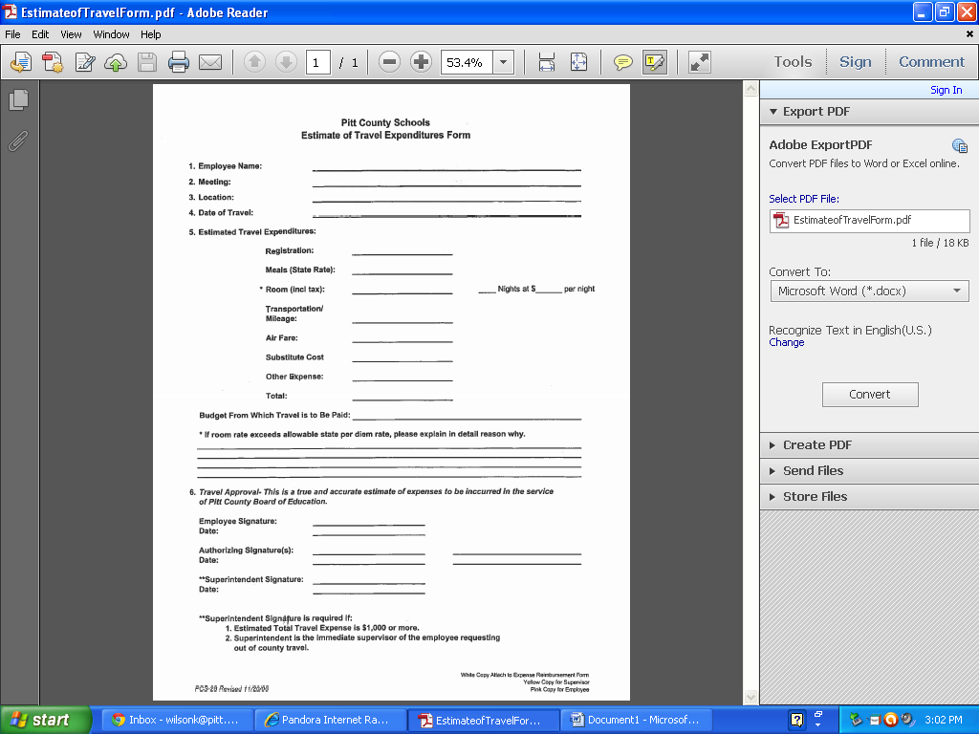

|  |  |  |  |  |  |  |  |  |  |  |
| --- | --- | --- | --- | --- | --- | --- | --- | --- | --- | --- |
| **Requisition Form** | | | | | | |  |  |  |  |
| **School __________________________________** | |  | **Date ____________________________** | | | |  |  |  |  |
|  |  |  |  |  |  |  |  |  |  |  |
| Please complete this form if you plan to **use Title I funds to purchase technology or computer equipment** for instructional purposes. This information is required by our Finance Department to develop/amend budgets for the fiscal year. | | | | | | | |  |  |  |
|  |  |  |  |  |  |  |  |  |  |  |
| Please note: Purchases are limited to the items specified below. Each item that was purchased for less than $1,000 per unit (including shipping/handling and taxes) needs to be purchased from one of the **budget codes 461, 462. 541, or 542.** | | | | | | | |  |  |  |
|  |  |  |  |  |  |  |  |  |  |  |
| **Budgeted Amount $ _________________ (must equal Total below).** | | | | | |  |  |  |  |  |
|  |  |  |  |  |  |  |  |  |  |  |
| **Description** | **# of units** | **List Price** | **Shipping/Handling** | **Sub-Total** | **Taxes** | **Unit Cost** | **Extended Cost** |  |  |  |
|  |  |  | 0.00 | 0.00 | 0.00 | 0.00 | 0.00 |  |  |  |
|  |  |  | 0.00 | 0.00 | 0.00 | 0.00 | 0.00 |  |  |  |
|  |  |  | 0.00 | 0.00 | 0.00 | 0.00 | 0.00 |  |  |  |
|  |  |  | 0.00 | 0.00 | 0.00 | 0.00 | 0.00 |  |  |  |
|  |  |  | 0.00 | 0.00 | 0.00 | 0.00 | 0.00 |  |  |  |
|  |  |  | 0.00 | 0.00 | 0.00 | 0.00 | 0.00 |  |  |  |
|  |  |  | 0.00 | 0.00 | 0.00 | 0.00 | 0.00 |  |  |  |
|  |  |  | 0.00 | 0.00 | 0.00 | 0.00 | 0.00 |  |  |  |
|  |  |  |  |  |  | **Total** | **0.00** |  |  |  |
| **Below, please include a statement indicating how each item will be used:** | | | | | | | |  |  |  |
| **Example - Storage cubbies will be used to meet pre-kindergarten licensing requirements.** | | | | | | | |  |  |  |
|  |  |  |  |  |  |  |  |  |  |  |
|  |  |  |  |  |  |  |  |  |  |  |
| **Justification for purchase?** | | | | | | | |  |  |  |
|  |  |  |
| **What is the plan usage?** | | | | | | | |  |  |  |
|  |  |  |
|  |  |  |
|  |  |  |
| **Where will the equipment be used?** | | | | | | | |  |  |  |
|  |  |  |
|  |  |  |

**Instructions for Preparation of   
Equipment Disposition Request**

FPD 212

(Rev 11/09)

|  |  |  |
| --- | --- | --- |
| A. | 1. Complete columns 1-4 for the items which will be purged from inventory 2. Complete column 5 for each item. Use **"Excellent, Good, Fair, Poor or Useless"** to describe the current condition. If the item cannot be located, and the condition is not known, use **"Unknown"**. However, a physical inventory of equipment must be taken and the results reconciled with the property records at least once every two years to verify the existence, current utilization, and continued need for the equipment. 3. Complete column 6 for each item with recommended action.    1. **Cannibalize** - Equipment that has become obsolete or unserviceable due to excessive repair costs, but still has serviceable component parts that can be used to repair, modify or construct other items of equipment.    2. **Beyond Repair - Discard** - Equipment that has been used beyond repair and the parts are not usable, and the item will be discarded.    3. **Lost** - Indicated the last date of inventory, and when the item of equipment was unable to be located.    4. **Stolen** - Attach a copy of the Official Police or Sheriff Investigation Report.    5. **Destroyed by Fire, Water, or Natural Disaster such as Flood, Wind, Snow, Ice, etc.** - Indicate insurance claim value as well as the date the claim was filed and attach a copy, if possible.    6. **No Longer Required** - The equipment is no longer needed for the operation of the program and is available for transfer or sale. Indicate "Transfer" or "On Loan to (other Federally funded Education Programs)" or "Sell at Auction" or "Sell Through Purchasing at a Fair Market Value" for any item of equipment with a unit cost of $5,000 or more. | |
| B. | The LEA Program Director signs to indicate approval of the request for disposition. | |
| C. | Mail completed form with cover letter of explanation to:  NC Department of Public Instruction  *Name of Program Administrator*  *Appropriate DPI Division*  *\*Use Appropriate Mail Service Center*  Raleigh, NC 27601-____ | A list of DPI Program Administrators is online at [www.ncpublicschools.org/docs/fbs/finance/federal/fedgrant.pdf](http://www.ncpublicschools.org/docs/fbs/finance/federal/fedgrant.pdf). |
| D. | The appropriate DPI Program Administrator will sign to indicate program approval and forward the form to the Monitoring & Compliance Section. | |
| E. | A notification will be mailed of the approved disposition action and any further disposition instructions if necessary. | |

North Carolina Department of Public Instruction

FPD 212

(Rev 11/09)

School Business Division

Monitoring & Compliance Section

# EQUIPMENT DISPOSITION REQUEST

PRC Number: ____ Federal Program: ____________________

LEA Number: ____ LEA Name: ________________________

|  |  |  |  |  |  |
| --- | --- | --- | --- | --- | --- |
| (1) | (2) | (3) | (4) | (5) | (6) |
| Description of  Equipment Item | Quantity Disposed | Month/Year  Purchased | Unit  Cost | Physical Condition | Disposition Action Recommended |
|  |  |  |  |  |  |
|  |  |  |  |  |  |
|  |  |  |  |  |  |
|  |  |  |  |  |  |
|  |  |  |  |  |  |
|  |  |  |  |  |  |
|  |  |  |  |  |  |
|  |  |  |  |  |  |
|  |  |  |  |  |  |
|  |  |  |  |  |  |
|  |  |  |  |  |  |

Approvals: Date:

LEA Federal

Program Director:

**State Level Use Only:**

**DPI Consultant:**

**Monitoring & Compliance**

**Section Staff:**

SAMPLE

**Pitt County Schools**

Student/Parent/Teacher/Principal Contract

Math Score: ______ Reading Score: ______

The State Board of Education and the Pitt County Board of Education have adopted policies requiring students to meet state and local standards for promotion in grades K-8 and for graduation from high school. The Boards believe that learning can take place best when there is shared effort, interest and motivation by students, parents and staff.

We are committed to ______________________’s success in school and promise to work together to promote his/her achievement.

STUDENT-I will:

* read every day;
* attend school regularly;
* come to class prepared, pay attention, and follow directions;
* complete all of my assignments, classwork and homework to the best of my ability every day;
* ask my teacher questions when I don’t understand;
* cooperate with my teacher, follow all school rules and Code of Conduct;
* always treat others the way I would like to be treated;
* realize that my education is the key to success; and
* deliver all correspondence, such as tests, progress reports, and letters between home and school.

Student: _________________________________

TEACHER-I will:

* explain my expectations, instructional goals, and grading systems to the student and parent;
* teach Common Core and Essential Skills;
* provide a climate in my classroom that is safe and encourages students to learn;
* regularly communicate with parents through conferences, progress reports, letters and by telephone;
* stress to students the importance of working at their potential and of meeting personal targets and promotion standards;
* employ various teaching methods which work best for the student;
* regularly assess student progress toward meeting the goals of the Common Core and Essential Skills and provide students and parents timely reports of progress;
* provide enrichment and remediation opportunities for the student as needed; and
* respect the cultural differences of my students.

Teacher: _________________________________

PARENT-I will:

* ensure that my child attends school regularly and remains in school for the entire instructional day;
* ensure that my child follows all school rules and procedures;
* support my child’s effort and achieve target scores;
* schedule daily study times for my child to complete homework;
* encourage my child to complete home assignments to the best of his or her ability;
* talk to my child about his or her school activities every day;
* encourage my child to read by reading to him or her;
* check, discuss, sign and return papers sent home by the teachers as requested;
* celebrate good news with my child, and encourage my child to do his or her best;
* ensure that my child is well rested and has breakfast every day at home or school;
* find out how my child is progressing by attending conferences, PTA/PTO meetings, and calling the school as necessary to set up conferences; and
* support the teacher and school.

Parent: _________________________________

PRINCIPAL-I will:

* create a welcoming environment for students and parents;
* communicate to student and parents the school mission and goals;
* promote a safe and orderly learning environment;
* reinforce the partnership between parent, student, and staff;
* act as the instructional leader by supporting teachers in their instruction of students; and
* provide the appropriate in-service and training for teachers and parents.

Principal: _______________________________

**Parent/School Compact**

A *Parent/School Compact* has been received by the school/classroom teacher for the following students:

**Student Name Compact Received**

**YES NO**

**_______________________________________ _____ _____**

**_______________________________________ _____ _____**

**_______________________________________ _____ _____**

**_______________________________________ _____ _____**

**_______________________________________ _____ _____**

**_______________________________________ _____ _____**

**_______________________________________ _____ _____**

**_______________________________________ _____ _____**

**_______________________________________ _____ _____**

**_______________________________________ _____ _____**

**_______________________________________ _____ _____**

**_______________________________________ _____ _____**

**_______________________________________ _____ _____**

**_______________________________________ _____ _____**

**_______________________________________ _____ _____**

**_______________________________________ _____ _____**

**_______________________________________ _____ _____**

**_______________________________________ _____ _____**

Monitoring



**Cross Program Consolidated Monitoring Desired Outcomes**

Cross Program Consolidated Monitoring focuses on indicators across common compliance strands of the following programs: Title I Part A, Title I, Part C (Migrant Education Program), Title I, Part D (Neglected and Delinquent), Title IV, Part A (Safe and Drug Free Schools), and Title VI (Rural Education Achievement Program). The desired outcome is to eliminate redundancy of compliance indicators and the duplication in reporting findings of noncompliance.

**Common Compliance Strands**

Above programs are reviewed using the following interrelated compliance strands:

1. **Stakeholder Involvement.** Parents, staff, students, and community members participate in developing, implementing, and evaluating programs at LEA and school levels.
2. **Governance, Administration and Funding.** Applications, plans, administration of programs, allocation and use of funds meet statutory requirements.
3. **Program Quality.** Programs are implemented using research-based strategies and services, highly qualified staff, and high quality professional development, all aligned to a comprehensive needs assessment.
4. **Accountability and Reporting.** Programs use state and other assessments to measure the achievement of intended outcomes of programs. LEA and schools publicly report and widely disseminate all required program and student accountability results.NCLB sanctions are properly implemented.

**Note:** Cross Program Consolidated Monitoring will consist of a 3 tiered approach.

**Tier I- Cross-Program Consolidated Self-Monitoring Instrument**- LEAs will use this instrument to measure compliance to designated program indicators.

**Tier II- Cross Program Consolidated Desk Review**- Sampling of evidence that support Self-Monitoring and Desk Review Instruments.

**Tier III- Cross Program Consolidated Monitoring Instrument-(On-Site)** -The cross program consolidated monitoring instrument (CPCMI) will be used by the SEA on-site to monitor those indicators that are common across programs. This instrument will be used to verify results and revisit findings in the LEA’s self-monitoring instrument and Desk Review.

NOTE: Because the methodology of the CPCM includes sampling, the monitoring process cannot produce an all-inclusive assessment of items in this instrument. The LEA is responsible for operating its categorical programs in compliance with all applicable laws and regulations.

Tier III Cross Program Consolidated Monitoring Instrument/ **On-Site**

|  |  |  |  |
| --- | --- | --- | --- |
| **LEA Name:** | **____________________________** |  | **LEA Programs**   * **Title I A** * **Title I C (MEP)** * **Title I D (N&D)** * **Title IV (SADF)** * **Title VI (RLIS/SRSA** |
| **LEA Contact Person:** |  |
| **SEA Monitoring Lead Person:** |  |
| **Date of Monitoring:**  **Date of Report:** |  |

|  |  |  |  |
| --- | --- | --- | --- |
| **Rating Scale Rubric** | | | |
| **Meets Requirements** | **Finding(s)** | **Action(s) Needed** | **NA- Not Applicable** |
| * Compliance indicator is 100% metand supported by all required evidence(s). * All Required documents are provided and support compliance. * Interviews support documentation, processes, and implementation. * Compliance is consistent at district and schools sampled. | * Evidence or lack of evidence show compliance indicator has not been met. * Incomplete or lack of required documentation. * Interviews lack understanding or support of documentation, processes, and implementation. * Compliance is inconsistent at district and school’s sampled. | * Recommendation(s) will address each finding. The LEA will respond to each recommendation with evidence of resolution. | * The District is not eligible for the program. * Accountability standard is not applicable. * Program not elected (i.e., pre-school, private school participation). |

**Strand I. Stakeholder Involvement.** Parents, staff, students, and community members participate in developing, implementing, and evaluating programs at the LEA and school levels.

**Indicators:**  The indicators below apply to the following programs: Title IA, School Improvement;

Title I A Section 1118

**Indicators**  **Standard Evidence(s)** 🞎(required)

|  |  |
| --- | --- |
|  |  |
| 1. Each school has adopted a school-level policy on parent involvement that is incorporated into school level plans.   Appendix A- Parent Involvement Policy Requirements | 🞎 A copy of School PI Policy-required  🞎 A copy of School Imp. Plan-required  Other : Meetings/Minutes on developing policy |
|  |  |
| 3. The LEA/School parent involvement policy is consistent with the following goals and purposes:   * 1. Documentation of parent involvement opportunities for all parents that are representative of the population in development of policies, parent-school compacts, and parent involvement activities.   2. Provides documentation of consultation opportunities for parents who are representative of population in the planning, implementation and evaluation of Title programs.   3. Provides evidence that parent involvement policies, compacts, information and involvement opportunities are disseminated and provided in a language and form that parents understand.   4. Provide parents with information and/or activities regarding curriculum standards, local and state assessment, how to monitor their child’s progress and how to contact and work with school staff.   5. Parent activities are planned and held to provide techniques and strategies that enable parents to assist their children at home.   6. Build consistent and effective communication between the home and the school.   Appendix A- Parent Involvement Policy Requirements | 🞎 A copy of School improvement Team and/or other parent planning committee.  🞎 Copies of minutes which support parent involvement in planning.  Other: Schedules; Interviews; Communications; Surveys  🞎 A copy of School improvement Team and/or other parent planning committee.  🞎 Copies of minutes which support parent involvement in planning.  In appropriate languages:  🞎 Copy of parent involvement policy  🞎 Copy of compact  🞎 Examples of newsletters or other  communications  🞎 Accountability information  🞎 School Improvement information  🞎 Schedule of activities and/or information  🞎 Sign-In sheets  🞎 Description of activities  Other: Interviews, communications  🞎 Schedule of activities  🞎 Sign-In sheets  🞎 Description of activities  Other: Interviews, communications  🞎 Examples of communications, newsletters, email, etc.  🞎 Schedule of parent teacher conferences |
|  | |
| 1. Parents notifications are provided (in appropriate languages):  * a. Annual Report Card * b. Individual Student Assessments * c. LEA/School Annual Progress (AYP/report card) * d. LEA/Schools identified as Priority or Focus * e. LEA/School Parental Involvement policies. * f. Grievance policies * g. Teacher/paraprofessionals qualifications (may request and review)   Non-highly qualified Teacher (must report to parents if student is being taught by non- HQ)   * h. Annual meeting/ Title I Part A & C information | 🞎 Copies and evidence of dissemination  🞎 Evidence of notification  🞎 Copies and evidence of dissemination  🞎 Copies and evidence of dissemination  🞎 Copies and evidence of dissemination  🞎 Policy (student planner, parent policy booklet, etc.)  🞎 Notification (student planner, parent policy booklet, etc.)  🞎 Notification (if applicable)  🞎 Agenda/ Minutes  🞎 Sign-In  Other supporting evidence: Interviews, email communications, webpage. |
|  | |

**Strand II. Governance, Administration and Funding.** Applications, plans, administration of programs, allocation and use of funds meet statutory requirements.

**Indicators:**  The indicators below apply to the following programs: Title I A , Title I C (MEP), Title IVA (SADFS), School Improvement and Title VI(SRSA & RLIS).

Title I Part A Section 1112 , 1113, 1116, 1119, 1120A & B; Section 1421, 1422, 1423,1424 Title I Part D;

**Indicators**  **Standard Evidence(s)** 🞎(required)

|  |  |
| --- | --- |
| Fiscal | |
|  | |
|  | |
| 1. The school maintains an inventory record for each piece of equipment, with an acquisition cost of $500 or more or a shelf life of several years, which is purchased with federal funds. The record is maintained by description of item, acquisition date, cost, and location. | 🞎Inventory list  Other: Disposition report for lost, obsolete or unusable equipment |
|  | |
| Time and Effort | |
| 1. Charges for wages and salaries of employees who work on multiple activities or cost objectives are supported by time and effort documentation.   OMB A-87 | 🞎Time and effort documentation |
|  | |
| 1. Salaries of employees who work on a single Federal award or cost objective are supported by periodic certification that the employees work solely on that program for the period covered by the certification.   OMB A-87 | 🞎Semi- Annual Certification statements |

**Strand III. Program Quality.** Programs are implemented using scientifically researched based strategies and services, highly qualified staff, and high quality professional development which is all aligned to a comprehensive needs assessment.

**Indicators:**  The indicators below apply to the following programs: Title I A, Title I C (MEP), Title IVA (SADFS), School Improvement and Title VI(SRSA & RLIS

Title I A Section 1113, 1114, 1119; Title I D 1423;

**Indicators Standard Evidence(s)** 🞎 (required)

|  |  |
| --- | --- |
|  | |
| * + - 1. **For all programs** operated at the school, the school improvement team and/ or other groups of stakeholders, annually review and update the school improvement plan. | 🞎 School Improvement Plan  🞎 SIT list  🞎 Agendas and minutes |
|  | |
| * + - 1. Schools have conducted a comprehensive needs assessment using multiple domains of data sources. | 🞎 School level comprehensive needs assessment  🞎 Data Sources |
|  | |
| * + - 1. Schools have developed measurable goals and objectives. | 🞎 School Improvement Plan  🞎 Prioritized Plan |
|  | |
| * + - 1. Scientifically researched-based reform strategies are implemented. | 🞎 School Improvement Plan  🞎 Sampling of lesson and unit plans  🞎 Sampling of Research evidence of strategies being used |
|  | |
| 5. Instruction is provided by a highly-qualified staff. | 🞎 Principal’s Attestation statement  🞎 Certification data  🞎 Notifications to parents if child’s teacher is not highly qualified. |
|  | |
| 6. High-quality and ongoing professional development is provided for school staff , pupil service personnel, parents and other applicable persons to enable all children to meet the State’s student academic achievement standards, and implement all Professional Development program requirements. | 🞎 Records of professional development opportunities.  Aligned to needs assessment |
|  | |
| 7. Strategies are implemented to attract high-quality, highly qualified teachers to schools with high needs. | 🞎 Recruitment and retention plans  🞎 Interview principal |
|  | |
| 8. Schools implement plans for assisting children in the transition from early childhood programs to local elementary schools; from middle school to high school and from N & D institutions to schools. | 🞎 Transition plan/strategies  🞎 Evidence of collaboration between school and preschool programs  🞎 N& D program description |
|  | |
| 9. Procedures are in place to ensure that students who experience difficulty mastering any of the proficient or advanced levels of academic standards are provided effective and timely additional assistance. | 🞎 Process of identification  🞎 Minutes for Student Assistant Teams  🞎 Instructional Intervention Plan  Other: Interview Principal, Intervention Team member |
|  | |
| 10. The school demonstrates coordination and integration of Federal, State, and local services and programs. | 🞎 Plans  🞎 Budgets  Other: Interview Principal, SIP team |
|  | |
| 11. Schools have developed comprehensive plans for reforming the total instructional program and promoting safe and healthy schools.  See Appendix G – Program components : Title I A | 🞎 School Improvement Plan  Other: Interview Principal, SIP team |
|  | |
| 12. School plans are in an understandable and uniform format and are available throughout the LEA to parents and the public. | 🞎 School Improvement Plan  🞎 Other relevant plans (SACS, Safe Schools, crate folders, etc)  Other: Interview Principal, SIP team |
|  | |
| 13. Title I, Part A paid staff assumes limited assigned duties that are relevant to similar personnel, including duties beyond classroom instruction or that do not benefit participating children. | 🞎 Title I staff schedules  🞎 Interview Title IA Teachers |
|  | |

**Strand IV. Accountability and Reporting.** Programs use state and other assessments to measure the achievement of intended outcomes of programs. The LEA and its schools publicly report and widely disseminate all required program and student accountability results.

**Indicators:**  The indicators below apply to the following programs: Title I A, Title I C (MEP), Title IVA (SADFS), School Improvement and Title VI(SRSA & RLIS

Title I A Section 1111, 1114, 1116; Title I D Section

**Indicators Standard Evidence(s)** 🞎 (required)

|  |  |
| --- | --- |
| Assessments | |
| * + - 1. Teachers are included in decisions regarding the use of assessments. | 🞎 Meeting agendas  🞎 Meeting minutes/notes  🞎 Common planning time agendas  Other: Title I Director, Principals, Teachers. |
|  | |
| * + - 1. Assessments are conducted on an ongoing basis and use multiple methods and sources of data. * Data identifies strengths and weaknesses * Data provides sufficient detail to plan appropriate instruction | 🞎 Assessment tools  🞎 Student Portfolios  Other: Interviews with Title I Pre-K Director, Pre-K Teacher |
|  | |
| School Report Cards | |
|  | |
| 1. The results of the annual review of all participating schools are publicized and disseminated to teachers and other school staff, parents, students and the community. | 🞎 Publicized results of annual review  🞎 Dissemination procedures  🞎 Evidence of dissemination (newspaper, webpage, cover letter,)  🞎 Other language translations as applicable  Other: Title I Director, MEP Director, Testing/Accountability staff. |
|  | |
| Identifying Schools: Focus, Priority, SIG | |
| 1. The LEA provides each school the opportunity to review school-level data. | 🞎 Verification report- Accountability/Testing Director has report  🞎Appeal information (if applicable)  Other: Interview Title I Director, Principals Testing/Accountability staff. |
|  | |
| School Improvement | |
|  | |
| 1. In consultation with parents, the LEA and the School Support Team, develop and/or revise their school plans for schools in School Improvement in ways that have the greatest likelihood of improving the performance of participating children and then submit such plans to the LEA for approval. | 🞎 Revised school improvement plans. (selected schools)  🞎 Evidence of consultation with parents(agendas, minutes, sign-in sheets)  🞎 Evidence of LEA technical assistance(meetings, staff development, materials provided by LEA)  🞎Evidence of LEA review and approval  Other: Interview Title I Director, Principals, School Improvement Team members, parents |
|  | |

**Schoolwide Program Quality Review Monitoring Instrument/ On-Site**

|  |  |  |  |
| --- | --- | --- | --- |
| **School Name:** |  |  | 🞎 **Focus School**   * **Priority School** * **SIG School** |
| **LEA Contact Person:** |  |  |
| **Date of Monitoring:** |  |  |
| **Date of Report:** |  |  |

|  |  |  |  |
| --- | --- | --- | --- |
| **Rating Scale Rubric** | | | |
| **Quality Indicators** | **Meets Requirements** | **Action(s) Needed** | **NA- Not Applicable** |
| * Documentation that needs to be included. | * Compliance indicator is 100% metand supported by all required evidence(s). * All Required documents are provided and support compliance. | * Evidence or lack of evidence show compliance indicator has not been met. * Incomplete or lack of required documentation. * Recommendation(s) will address each finding. The school will respond to each recommendation with evidence of resolution. | * The school is not eligible for the program. * Accountability standard is not applicable. * Program not elected (i.e., pre-school, private school participation). |

**Strand II. Governance, Administration and Funding.** Applications, plans, administration of programs, allocation and use of funds meet statutory requirements.

|  |  |  |  |  |
| --- | --- | --- | --- | --- |
| **Fiscal** | | | | |
| 1. The school maintains an inventory record  for each piece of equipment, with an  acquisition cost of $500 or more or a shelf  life of several years, which is purchased  with federal funds. The record is  maintained by description of item,  acquisition date, cost, and location. | □ Inventory List or Destiny file  □ Disposition report for lost, obsolete or unusable equipment  □ Check on equipment labeling |  |  |  |
| **Time and Effort** | | | | |
| 2. Charges for wages and salaries of employees who work on multiple activities or cost objectives are supported by time and effort documentation. OMB A-87 (PreK staff only) | □ Copy of PAR  □ Copy of Time and Effort from Finance |  |  |  |
| 3. Salaries of employees who work on a single Federal award or cost objective are supported by periodic certification that the employees work solely on that program for the period covered by the certification. OMB A-87 | □ Copy of Time and Effort from Finance  □ Semi-annual Certification statements |  |  |  |

**Strand III. Schoolwide Program Quality.** Programs are implemented using scientifically researched based strategies and services, highly qualified staff, and high quality professional development which is all aligned to a comprehensive needs assessment.

|  |  |  |  |  |
| --- | --- | --- | --- | --- |
|  | **Quality Indicators** | **Meets Requirements** | **Action Needed** | **Not Applicable** |
| * + - 1. School plan was developed in consultation with parents and other members of the community including teachers, principals, and administrators. (If secondary school, students are included in the consultation). [SEC. 1114(b)(2)(B)(ii)] | □ Agendas/Minutes of meetings (e.g., parents, community, school improvement team, etc.)  □ Sign-in sheets |  |  |  |
| * + - 1. School plan is available to the LEA, parents, and the public. [SEC. 1114(b)(2)(B)(iv)] | □ Public notices  □Communication to parents  □ Evidence of the annual meeting |  |  |  |
| * + - 1. School plan is reviewed and revised as necessary. [SEC. 1114(b)(2)(B)(iii)] | □ School Improvement Plan  □ List of school improvement team members  □ Agendas  □ Minutes of meetings |  |  |  |
| * + - 1. School conducts a comprehensive needs assessment including achievement of children related to State academic content standards and the State student academic achievement standards. [SEC. 1114(b)(1)(A)] | □ School data (e.g., narratives, charts, graphs) from multiple sources  □ Agendas/minutes of meetings  □ School plan based on CAN  □ Surveys, communications, interviews |  |  |  |
| * + - 1. Schoolwide reform strategies: 1) use effective methods and instructional strategies that are based on scientifically based research; 2) provide opportunities for all children to meet the State’s proficient and advance levels of student academic achievement; and 3) include strategies to address the needs of all children particularly the lowest achieving and how those needs will be met. [SEC. 1114(b)(1)(B)(i)]; SEC. 1114(b)(1)(B)(ii)]; SEC. 1114(b)(1)(B)(iii)] | □ School Improvement Plan  □ Teacher schedules  □ Evidence of extended learning opportunities  □ Sample lesson and unit plans  □ Student Personal Education Plans  □ Benchmark data  □ Formative Assessments  □ Sampling of research evidence of strategies being used |  |  |  |
| 1. Instruction is provided by a highly-qualified staff.   [SEC. 1114(b)(1)(C)] | □ Principal Attestation Statement  □ Certification data  □ Human resources reports  □ Notification to parents of non-HQ issues |  |  |  |
| 7. High-quality and ongoing professional development is provided for school staff. [SEC. 1114(B)(1)(D)] | □ Professional development plans  □ Agendas/Minutes of meetings (planning and implementation)  □ Sign-in Sheets  □ Mentor/lead teacher schedules |  |  |  |
| 8. School engages in strategies to attract high-quality, highly qualified teachers. [SEC. 1114(b)(1)(E)] | □ School Improvement Plan  □ Records of recruitment and retention activities |  |  |  |
| 1. School engages in strategies to increase parental involvement [SEC. 1114(b)(1)(F)] | □ Parent involvement plan  □ Parent Compacts  □ Parent notifications/ newsletters  □ Agendas/minutes from annual meeting  □ Communication for non-English speakers  □ Parent training sessions |  |  |  |
| 1. Schools implement plans for assisting children in the transition from early childhood programs to local elementary schools; from middle school to high school and from N & D institutions to schools. [SEC. 1114(b)(1)(G)] | □ School Improvement Plan  □ Evidence of transition activities  □ Transition plans/strategies |  |  |  |
| 1. School implements measures to include teachers in the decisions regarding the use of academic assessments to improve student achievement and the instructional program of the school. [SEC. 1114(b)(1)(H)] | □ Grade level meeting agendas/minutes  □ Professional development agendas, sample materials, sign-in sheets  □ Benchmark data  □ Sample lesson plans |  |  |  |
| 1. Activities that are provided to students with difficulty mastering standards is effective, timely, and based on sufficient information. [SEC. 1114(b)(1)(I)] | □ Personal Education Plans  □ Sample student assessments  □ Minutes for Student Assistance Plan |  |  |  |
| 1. School effectively coordinates and integrates available resources provided with Federal, State, and local funds. [SEC. 1114(b)(1)(J)] | □ School Improvement Plans  □ Budgets  □ School Improvement team minutes |  |  |  |

**Strand IV. Accountability and Reporting.** Programs use state and other assessments to measure the achievement of intended outcomes of programs. The LEA and its schools publicly report and widely disseminate all required program and student accountability results.

|  |  |  |  |  |  |
| --- | --- | --- | --- | --- | --- |
|  | **Quality Indicators** | | **Meets Requirements** | **Action Needed** | **Not Applicable** |
| **Assessments** | | | | | |
| 1. Assessments are conducted on an ongoing basis and use multiple methods and sources of data.   * Data identifies strengths and weaknesses * Data provides sufficient detail to plan appropriate instruction | □ Personal Education Plans  □ Sample student assessments  □ Student portfolios |  | |  |  |
| **School Report Cards** | | | | | |
| 2. The results of the annual review of all participating schools are publicized and disseminated to teachers and other school staff, parents, students and the community. | □ School Report Card  □ Evidence of dissemination |  | |  |  |
| **School Improvement** | | | | | |
| 3. In schools identified as Focus or Priority school parents receive written notification. | □ Letter to parents |  | |  |  |
| 4. In consultation with parents, the LEA and the School Support Team, develop and/or revise their school plans for schools. Submit such plans to the LEA for approval. | □ School Improvement Plan revisions  □ Evidence of consultation with parents (agendas, sign in sheets, minutes of meeting) |  | |  |  |

**Title I Parent Involvement Quality Review Monitoring Instrument/ On-Site**

|  |  |  |  |
| --- | --- | --- | --- |
| **School Name:** |  |  | 🞎 **LEA Improvement __________ year(s)**   * **SES** * **Corrective Action** * **Restructuring (planning )** * **Restructuring (implementation)** |
| **LEA Contact Person:** |  |  |
| **Date of Monitoring:** |  |  |
| **Date of Report:** |  |  |

|  |  |  |  |
| --- | --- | --- | --- |
| **Rating Scale Rubric** | | | |
| **Quality Indicators** | **Meets Requirements** | **Action(s) Needed** | **NA- Not Applicable** |
| * Documentation that needs to be included. | * Compliance indicator is 100% metand supported by all required evidence(s). * All Required documents are provided and support compliance. | * Evidence or lack of evidence show compliance indicator has not been met. * Incomplete or lack of required documentation. * Recommendation(s) will address each finding. The school will respond to each recommendation with evidence of resolution. | * Accountability standard is not applicable. |

**Strand I. Stakeholder Involvement.** Parents, staff, students, and community members participate in developing, implementing, and evaluating programs at the LEA and school levels.

|  |  |  |  |  |
| --- | --- | --- | --- | --- |
| **I. School Parent Involvement Plan: Has the written plan been developed and communicated with all stakeholders to support effective parent involvement?** | | | | |
| **Quality Requirement** | **Quality Indicator Findings** | **Meets Requirements** | **Action Needed** | **Not Applicable** |
| * + - 1. Title I school **jointly develops with parents** a written parental involvement policy, agreed on by such parents, that shall describe how the school will implement the Parent Involvement Policy [SEC. 1118(b)(1)] | □ Agendas/Minutes of meetings (e.g., parents, community, school improvement team, etc.)  □ Sign-in sheets |  |  |  |
| * + - 1. The school plan is disseminated to families of students in Title I programs. [SEC 1118(b)(1)] | □ Parent communications  □ Agendas/Minutes of meetings  □ Sign-in sheets |  |  |  |
| * + - 1. The plan is made available to the local community and updated periodically to meet the changing needs of parents and the school. [SEC. 1118(b)(1)] | □ Parent Involvement Plan  □ List of parent involvement committee members  □ Evidence of the annual meeting  □ Agendas/Minutes of meetings  □ Sign-in sheets |  |  |  |
| * + - 1. The plan is written in an understandable and uniform format and, to the extent practicable, provided in a language the parents can understand. [SEC 1118(b)(1)] | □ Parent Involvement Plan  □ Interview with parents |  |  |  |
| **II. Parent Opportunities: Are parents provided with meaningful opportunities to engage in supporting the academic achievement of their children?** | | | | |
| **Quality Requirement** | **Quality Indicator Findings** | **Meets Requirements** | **Action Needed** | **Not Applicable** |
| 1. Title I schools convene an annual meeting, at a convenient time, to which all parents are invited and encouraged to attend. [SEC. 1118(c)(1)] | □ Parent communications/ notification  □ Agendas/Minutes of Annual/open meeting  □ Sign-in sheets  □ Materials used at the meeting |  |  |  |
| 1. The school offers a flexible number of meetings and services related to parental involvement. [SEC. 1118(c)(2)] | □ Schedule of meetings  □ Sample parent communications  □ Agendas/materials from meeting  □ Sign-in sheets  □ Teacher home visit logs |  |  |  |
| 1. The school includes an adequate representation of parents of students in the school in the planning, review, and improvement of programs and plans of the school (minimum 2 parents). [SEC. 1118(c)(3)] | □ School Improvement Team rosters  □ Schedule/ announcements of meetings  □ Agendas/Minutes of meetings  □ Interviews with parents |  |  |  |
| 4. The school **jointly develops with parents** a school-parent compact that outlines how parents, the entire school staff, and students will share the responsibility for improved student academic achievement. [SEC. 1118(d)] | □ Sample signed parent compacts  □ Agendas/schedules of meetings to discuss shared responsibility |  |  |  |
| 5. The school addresses the importance of communication between teachers and parents on an ongoing basis. [SEC. 1118(d)(2)] | □ Communication to parents  □ Parent-teacher conference schedules  □ Minutes of conferences  □ Sign-in sheets  □ Volunteer logs |  |  |  |
| **III. Building Capacity for Involvement: Does the school effectively support a partnership among staff, parents, and the community?** | | | | |
| **Quality Requirement** | **Quality Indicator Findings** | **Meets Requirements** | **Action Needed** | **Not Applicable** |
| 1. The school provides assistance to parents in understanding such topics related to academic achievement of their students. [SEC 1118(e)(1)] | □ Communication to parents  □ Parent –Teacher conference schedules  □ Minutes of conferences  □ Sign-in sheets  □ Agendas/ Minutes of meetings  □ Interview with parents |  |  |  |
| 1. The school provides materials and training to help parents to work with their children. [SEC. 1118(e)(2)] | □ Written parent involvement policy/plan  □ Schedule of training opportunities  □ Sample materials from training such as literacy training and using technology |  |  |  |
| 1. The school educates school staff on the value and utility of parent involvement. [SEC. 1118(e)(3)] | □ Professional development plan  □ Schedule of training opportunities  □ Agendas  □ Sign-in sheets  □ Sample materials from training |  |  |  |
| 1. The school provides information to parents related to school and parent programs. [SEC. 1118(e)(5)] | □ Sample parent communications |  |  |  |
| 1. The school provides reasonable support for parental involvement activities if parents request the support. [SEC. 1118(e)(14)] | □ Sample parent communications |  |  |  |

|  |
| --- |
| Comments: |

**Title I Pre-Kindergarten Quality Review Monitoring Instrument/ On-Site**

|  |  |  |  |  |  |  |
| --- | --- | --- | --- | --- | --- | --- |
| **School Name:** |  | | |  | 🞎 **LEA Improvement __________ year(s)**   * **Corrective Action** * **Restructuring (planning )** * **Restructuring (implementation)** | |
| **LEA Contact Person:** |  | | |  |
| **Date of Monitoring:** |  | | |  |
| **Date of Report:** |  | | |  |
|  |  | | |  |  | |
| **Rating Scale Rubric** | | | | | | | |
| **Quality Indicators** | | **Meets Requirements** | **Action(s) Needed** | | | **NA- Not Applicable** | |
| * Documentation that needs to be included. | | * Compliance indicator is 100% metand supported by all required evidence(s). * All Required documents are provided and support compliance. | * Evidence or lack of evidence show compliance indicator has not been met. * Incomplete or lack of required documentation. * Recommendation(s) will address each finding. The school will respond to each recommendation with evidence of resolution. | | | * Accountability standard is not applicable. | |

**Strand III. Program Quality.** Programs are implemented using scientifically researched based strategies and services, highly qualified staff, and high quality professional development which is all aligned to a comprehensive needs assessment.

|  |  |  |  |  |
| --- | --- | --- | --- | --- |
| **I. Selection Process: Have students been appropriately selected for services?** | | | | |
| **Quality Requirement** | **Quality Indicator Findings** | **Meets Requirements** | **Action Needed** | **Not Applicable** |
| * + - 1. If Title I preschool program is held at a schoolwide program, pre-k students are identified within the attendance area for that school. [SEC. 1114(a)(2)] | □ Roster of enrolled students  □ Process for enrollment |  |  |  |
| * + - 1. Children are selected on the basis of such criteria as teacher judgment, interviews with parents, and developmentally appropriate educationally related measures. [SEC 1115(b)] | □ Assessment results  □ Teacher input  □ Parent interviews/surveys  □ Rank order list of students  □ Roster of participating students |  |  |  |
| **II. Instruction: Are the required components effectively communicated to staff and implemented in the preschool program?** | | | | |
| **Quality Requirement** | **Quality Indicator Findings** | **Meets Requirements** | **Action Needed** | **Not Applicable** |
| 1. Title I funds are used to help participating children meet such State’s challenging student academic achievement standards. [SEC. 1115(c)(2)] | □ Review classroom schedule—provides a balanced program of child-initiated & adult-directed learning experiences, including individual and small group activities, both indoors and outdoors  □ Daily schedule provides opportunity for sustained creative play |  |  |  |
| 1. The pre-k program implements effective methods and instructional strategies that are based on scientifically based research. [SEC. 1118(c)(2)] | □ Curriculum is comprehensive, developmentally appropriate, supports a broad range of interests and abilities, and aligns with NC’s early learning standards  □ Sample teacher lesson plan used for student instruction  □ Student portfolio/work samples  □ Assessment tool utilized to measure progress |  |  |  |
| 1. Instruction is provided by highly qualified teachers. [SEC. 1115(c)(1)(E)] | □ Teachers possess Birth to Kindergarten licensure and/or Pre-K add on licensure  □ Paraprofessionals meet required qualifications under ESEA |  |  |  |
| **III. Monitoring: Does the LEA maintain control of funds and title to materials and equipment purchased with Title I funds?** | | | | |
| **Quality Requirement** | **Quality Indicator Findings** | **Meets Requirements** | **Action Needed** | **Not Applicable** |
| 1. Title I materials and equipment are used solely for students participating in the PreK program. [SEC 1115] | □ Budgets  □ Purchase orders/invoices  □ Labeled Title I equipment  □ Equipment inventory sheet  □ Contracts (if applicable) |  |  |  |
| 1. Title I personnel (teachers, paraprofessionals, coordinators, etc.) have their Title I time and daily duties documented through a fixed schedule. | □ Payroll records  □ Semi-Annual certification documentation in compliance  □ Title I staff schedules |  |  |  |
| **IV. Parent Involvement: Does the school ensure effective parent involvement to support student achievement?** | | | | |
| **Quality Requirement** | **Quality Indicator Findings** | **Meets Requirements** | **Action Needed** | **Not Applicable** |
| 1. The school implements strategies to increase parental involvement [SEC. 1118 | □ Parent Interview |  |  |  |
| 1. The school implements strategies to increase parental involvement. [SEC. 1118] | □ School parent involvement policy includes pre-k program  □ Ongoing parent notifications/ newsletters  □ Agendas/minutes from annual meeting  □ Communication for non-English speakers  □ Parent training sessions |  |  |  |